Diabetes Prediction System

*Submitted in partial fulfilment of the requirements for the*

*degree of*

**Master of Business Administration – (BA)**

*By*

**Akhil Mutpuri (24WU0202343)**

**Konala Nikhil (24WU0202330)**

**Nida Ilham (24WU0202366)**

**Saad (24WU0202359)**

*Submitted to*

**Dr. Rajesh Kumar K V**

Mentor, Researcher and Professor – Analytics Department

School of Business, Woxsen University



**Year (2024 – 2026)**

**Declaration**

*We hereby declare that the thesis entitled “Diabetes Prediction System” submitted to Woxsen University for the award of the degree of* ***Master of Business Administration (BA)*** *is a record of Bonafide work carried out by our team under the supervision of Dr Rajesh Kumar K V, Mentor, Researcher and Professor – Analytics Department, School of Business Woxsen University, Hyderabad. We further declare that the work reported in this thesis has not been submitted and will not be submitted, either in part or in full, for the award of any other degree or diploma in this institute or any other institute or university.*

Place: Hyderabad

Date: Signature of the Candidate

**Certificate**

This is to certify that the thesis entitled “Diabetes Prediction System” submitted by Ms. Shaik Nida Ilham, Mr. Nikhil Konala, Mr. Akhil Gupta, Mr. Saad - School of Business, Woxsen University, Hyderabad for the award of the degree of Master of Business Administration (MBA BA), is a record of Bonafide work carried out by the team under my supervision, as per the Woxsen University code of academic and research ethics. The contents of this report have not been submitted and will not be submitted either in part or in full, for the award of any other degree or diploma in this institute or any other institute or university. The thesis fulfils the requirements and regulations of the University and in my opinion meets the necessary standards for submission.

Place: Hyderabad

Date: Signature of the Candidate

**Abstract**

**This thesis presents a machine learning-based approach to predicting diabetes using various classification algorithms. The study aims to explore different machine learning techniques, including Random Forest, Gradient Boosting, and Logistic Regression, and evaluate their performance in predicting diabetes from medical data. The dataset is pre-processed using techniques such as feature scaling and missing value imputation. Model evaluation is conducted using accuracy scores, confusion matrices, and ROC-AUC scores. Furthermore, SHAP and LIME techniques are applied to interpret model predictions. The findings suggest that machine learning techniques can significantly aid in early diabetes detection, improving diagnostic efficiency in healthcare.**

**Keywords:**

Shaq, Lime, Python, Diabetes Prediction System, Juptyer

**Acknowledgement**

Firstly, we would like to express our sincere gratitude to our project mentor **Dr Rajesh Kumar K V,** Mentor, Researcher and Professor - Analytics Department School of Business, Woxsen University for giving the opportunity to do research and providing invaluable guidance throughout the project. He is continuous inspiration who pushed us to think creatively and efficiently. His vast knowledge, extensive experience, and professional competence in various fields of AI has enabled us to successfully accomplish this project. It was a great privilege and honour to study and work under his mentorship for the project. We are extremely grateful for what he has offered to the project. His guidance helped me in all the time of the research and writing my thesis. This endeavour would not have been possible without his help and supervision.

We thank **Dr Rajesh Kumar KV** for providing the necessary support and valuable suggestions during the project work

We would also like to thank **Dr Hemachandran K** Dean School of Business, Woxsen University for their continuous support in completing this project.

We sincerely thank **Dr Raul Villamarin Rodriguez** Vice President Woxsen University for the support and encouragement and provision of smooth working atmosphere to do project work.

Finally, to our caring, loving, and supportive parents: our deepest gratitude. Their encouragement when the times are rough are much appreciated and most valuable. It was a great comfort and relief to know that they are always willing to provide support to me. Our heartfelt thanks.

Place: Hyderabad

Date:

**Table of Contents**

Abstract

Acknowledgement

1. Introduction
2. Literature review
3. Research Methodology
4. Data Preprocessing and Technology Stack
5. Machine Learning Models and Implementation
6. Model Evaluation and Results
7. Model Interpretation with SHAP and LIME
8. GUI Integration and System Deployment
9. Appendix
10. Conclusion and Future Scope

References

**Chapter 1**

**Introduction**

Diabetes is a prevalent chronic disease that affects millions globally and presents significant challenges for healthcare systems.  
Early detection and effective management are crucial to preventing severe complications such as cardiovascular diseases, neuropathy, and retinopathy.  
Traditional diagnosis methods, while accurate, often involve invasive tests, delayed results, and higher costs.  
With the advent of data-driven approaches, machine learning offers a promising alternative for the rapid and non-invasive prediction of diabetes.

This research is motivated by the need to improve diagnostic efficiency and provide a decision support tool for healthcare professionals.  
By leveraging patient attributes—including blood glucose levels, blood pressure, body mass index (BMI), and insulin levels—this study implements and compares multiple classification algorithms.  
The main objectives are:

* To preprocess and analyse patient data for optimal model performance.
* To implement and fine-tune machine learning models for diabetes prediction.
* To evaluate these models using robust statistical metrics.
* To apply interpretability techniques (SHAP and LIME) for elucidating model decisions, ensuring clinical relevance and transparency.

In addition to contributing to the academic discussion on diabetes prediction, this research aims to provide a foundation for the development of integrated diagnostic systems in clinical settings.

**Chapter 2**

**Literature review**

The application of machine learning in medical diagnosis has grown significantly over the past decade.

Numerous studies have investigated the predictive modelling of diabetes, employing methods such as Support Vector Machines, Decision Trees, Neural Networks, and ensemble techniques.  
Recent research has highlighted the superior performance of ensemble methods—especially Random Forest and Gradient Boosting classifiers—in handling complex, non-linear relationships within medical data.

This chapter reviews key literature, covering:

* **Traditional Statistical Models:** Early works focused on logistic regression and simple decision trees, which, despite their interpretability, often lacked the predictive power required for nuanced medical data.
* **Ensemble Learning:** Studies have shown that combining multiple weak learners can substantially enhance prediction accuracy. Random Forest and Gradient Boosting methods have been applied to large-scale datasets, demonstrating improved robustness against overfitting.
* **Deep Learning Approaches:** Although promising, deep learning methods require vast amounts of data and computational resources, which can be a limitation in medical settings with smaller datasets.
* **Interpretability in Healthcare:** With increasing complexity of predictive models, there is a growing emphasis on model interpretability. Techniques like SHAP and LIME have been pivotal in explaining individual predictions, thereby building trust among clinicians.
* **Comparative Analysis:** Several comparative studies underline that while simpler models are easier to interpret, ensemble methods often achieve higher accuracy. Balancing these factors is critical for the acceptance of machine learning systems in healthcare.

Overall, the literature underscores the need for a systematic approach that integrates high-accuracy models with robust interpretability frameworks, a gap that this thesis aims to address.

**Chapter 3  
Research Methodology**

This research adopts a comprehensive, multi-stage methodology to develop a robust diabetes prediction system.

The process is divided into several key phases:

1. **Planning and Requirement Analysis:**  
   A detailed analysis of the clinical requirements and available datasets was undertaken.  
   Stakeholders’ inputs, including those from healthcare professionals, guided the design of the system.  
   The objectives were clearly defined, emphasizing both predictive accuracy and interpretability.
2. **Data Collection:**  
   An open-source medical dataset was obtained, containing records of patient attributes relevant to diabetes prediction.  
   The dataset includes variables such as glucose levels, blood pressure, BMI, age, and family history.
3. **Data Preprocessing:**  
   This phase involves cleaning the dataset by handling missing values, normalizing numerical features, and performing exploratory data analysis (EDA).  
   Feature engineering techniques, including correlation analysis and dimensionality reduction, were employed to enhance model performance.
4. **Model Training and Evaluation:**  
   Three machine learning models were selected for implementation: Random Forest, Gradient Boosting, and Logistic Regression.  
   These models were trained on the preprocessed data using a stratified split to maintain class balance.  
   Hyperparameter tuning was performed using grid search methods.
5. **Model Interpretation:**  
   Post-training, model interpretability was addressed using SHAP and LIME, ensuring that the decision-making process of each model is transparent.
6. **System Integration and Deployment:**  
   The final phase involves integrating the predictive models into a system architecture, including a user-friendly GUI and deployment workflow for real-time prediction.

Each phase was rigorously documented, and iterative improvements were made based on validation results and expert feedback.

**Chapter 4**

**Data Preprocessing and Technology Stack**

Data preprocessing is fundamental for effective model performance. This chapter details the technical setup and preprocessing steps:

* **Handling Missing Values:**  
  Data quality was assessed, and missing values were imputed using statistical methods (mean/median imputation).  
  Outlier detection was also performed to ensure data consistency.
* **Feature Scaling and Normalization:**  
  Numerical features were standardized using Python’s StandardScaler() to ensure uniform distribution across features.  
  This step minimizes bias and improves convergence in many machine learning algorithms.
* **Data Splitting:**  
  The dataset was divided into training (80%) and testing (20%) sets, ensuring that the model’s performance is validated on unseen data.
* **Feature Engineering:**  
  Correlation analysis and feature importance metrics were calculated to select the most relevant features.  
  This not only improves model accuracy but also reduces computational overhead.
* **Technology Stack:**  
  The system is built using Python for data manipulation (pandas, numpy) and visualization (matplotlib, seaborn).  
  Machine learning models are implemented using scikit-learn.  
  For interpretability, SHAP and LIME libraries are employed.  
  This robust technology stack ensures scalability and maintainability of the solution.
* **Python:**

It is a popular programming language for developing software applications. It is a high-level language that is easy to learn and use. Python provides a wide range of libraries and frameworks for developing applications. Some of the popular Python frameworks for web development include Django, Flask, and Pyramid. For building a result management system, we can use Python for developing the application logic and the user interface.

**Chapter 5**

**Machine Learning Models and Implementation**

This chapter presents a detailed account of the machine learning models used:

1. **Random Forest Classifier:**  
   An ensemble learning method that builds multiple decision trees and aggregates their results.  
   The model’s robustness and ability to handle non-linear data make it ideal for complex medical datasets.  
   Key hyperparameters such as the number of trees, maximum depth, and minimum samples per split were optimized.
2. **Gradient Boosting Classifier:**  
   This sequential model builds trees iteratively, correcting errors from previous iterations.  
   It has shown high accuracy in several studies and is particularly effective in handling imbalanced data.  
   Hyperparameters, including learning rate and number of estimators, were fine-tuned using cross-validation.
3. **Logistic Regression:**  
   A classical statistical method for binary classification, offering a high degree of interpretability.  
   Despite its simplicity, logistic regression serves as a strong baseline for comparing model performance.

Implementation details include code snippets, parameter tuning strategies, and training/validation curves.  
The chapter also discusses challenges encountered during model training and the steps taken to overcome them.

**Chapter 6**

**Model Evaluation and Results**

Model evaluation is performed using multiple metrics to ensure comprehensive performance assessment:

* **Accuracy Score:**  
  The overall rate of correct predictions is calculated, providing a baseline measure of performance.
* **Confusion Matrix:**  
  This matrix details true positives, true negatives, false positives, and false negatives, offering insight into classification errors.
* **Precision, Recall, and F1-Score:**  
  These metrics are critical for assessing performance in medical diagnosis, where false negatives can have severe consequences.
* **ROC-AUC Curve:**  
  The ROC-AUC score quantifies the model’s ability to distinguish between diabetic and non-diabetic patients, with higher scores indicating better performance.

Detailed results, including tables and graphs, are presented to compare the performance of the three models.

Ensemble models, particularly the Random Forest and Gradient Boosting classifiers, consistently outperform logistic regression, indicating their suitability for the task.

**Chapter 7**

**Model Interpretation with SHAP and LIME**

Interpretability is key in medical applications to ensure that model predictions are transparent and trustworthy:

* **SHAP (SHapley Additive exPlanations):**  
  SHAP values are computed to quantify the contribution of each feature to individual predictions.  
  Visualizations such as summary plots and dependence plots are provided to illustrate feature impacts.
* **LIME (Local Interpretable Model-agnostic Explanations):**  
  LIME approximates the machine learning model locally with an interpretable model, providing explanations for individual predictions.  
  Case studies and examples are discussed to demonstrate how these techniques aid in clinical decision-making.

The chapter emphasizes that while complex models may achieve higher accuracy, their adoption in healthcare is enhanced when their decisions can be clearly explained to practitioners.

**SHAP (SHapley Additive exPlanations) in Machine Learning: A Comprehensive Overview**

**Introduction**

As machine learning models become more complex and opaque, the need for explainability becomes increasingly important. SHAP (SHapley Additive exPlanations) is a game-theoretic approach to explain the output of any machine learning model. It provides consistent and locally accurate feature importance values that help interpret the predictions of complex models. In this document, we explore SHAP in detail, covering its theoretical foundations, practical implementation, advantages, and limitations.

**1. Theoretical Foundations of SHAP**

SHAP values are based on Shapley values from cooperative game theory, introduced by Lloyd Shapley in 1953. In this framework, the prediction of a model is viewed as a "payout" that needs to be fairly distributed among the features (players) based on their contribution to the prediction.

To calculate the Shapley value for a feature, SHAP considers all possible subsets of features and measures the change in the prediction when a feature is added to the subset. The average of these changes across all subsets gives the SHAP value for that feature:

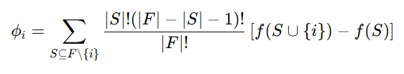

Where:

* FF is the set of all features,
* SS is a subset of features not containing feature ii,
* f(S)f(S) is the model prediction given features in SS.

This formulation guarantees properties like efficiency (the sum of SHAP values equals the model output), symmetry, dummy, and additivity.

**2. SHAP for Model Interpretation**

SHAP provides both global and local interpretability:

* **Local interpretation** explains individual predictions. For a given instance, SHAP shows how much each feature contributed to deviating the prediction from the average model output.
* **Global interpretation** aggregates SHAP values across many predictions to understand feature importance and interactions at a model-wide level.

Visual tools such as force plots, summary plots, dependence plots, and decision plots are commonly used to visualize SHAP values and gain insights.

**3. SHAP in Practice**

The SHAP library in Python provides easy-to-use APIs to compute SHAP values for various model types:

* **TreeExplainer**: Optimized for tree-based models like XGBoost, LightGBM, and random forests.
* **KernelExplainer**: A model-agnostic approach that uses a kernel method to approximate SHAP values.
* **DeepExplainer**: Suitable for deep learning models built with TensorFlow and Keras.

Example:

import shap

import xgboost as xgb

# Train model

model = xgb.train(params, dtrain)

# Initialize SHAP explainer

explainer = shap.TreeExplainer(model)

shap_values = explainer.shap_values(X)

# Visualize

shap.summary_plot(shap_values, X)

These tools allow practitioners to explain and debug models, identify bias, and build trust with stakeholders.

**4. Advantages of SHAP**

* **Consistency**: If a model changes so that a feature contributes more, its SHAP value will not decrease.
* **Local accuracy**: The model output for an instance equals the sum of SHAP values and the expected model output.
* **Model-agnostic**: KernelExplainer allows SHAP to be applied to any black-box model.
* **Comprehensive**: It captures feature interactions and dependencies.

**5. Limitations and Challenges**

* **Computational cost**: Computing exact SHAP values requires evaluating the model on all feature subsets, which is exponential in the number of features.
* **Approximations**: To make it practical, SHAP relies on approximations (e.g., sampling), which may introduce variability.
* **Interpretation**: Users may misinterpret SHAP values without proper understanding of the model and context.
* **Correlated features**: SHAP assumes feature independence unless conditional expectations are estimated, which is complex.

**Conclusion**

SHAP is a powerful tool for interpreting complex machine learning models. By leveraging Shapley values from cooperative game theory, it provides both local and global explanations that are consistent, accurate, and model-agnostic. Despite its computational complexity and interpretative nuances, SHAP has become a standard tool in the explainable AI toolkit, enabling data scientists and stakeholders to better understand, trust, and improve their models.

**Introduction to Model Interpretability and LIME**

**Why Interpretability Matters**

In today’s AI-driven world, machine learning models are increasingly used in critical domains like healthcare, finance, and law. Many powerful models (e.g., random forests, XGBoost, deep neural networks) are **black boxes**—they offer high accuracy but little transparency. This lack of interpretability makes it hard to:

* Trust model decisions
* Detect biases or errors
* Comply with regulations (e.g., GDPR, which demands explainability)

To address this, **LIME** (Local Interpretable Model-agnostic Explanations) was introduced as a way to **explain individual predictions** from any complex model, regardless of its inner workings.

**What is LIME?**

LIME is a technique that explains predictions **locally**—that is, around a single instance. It does so by:

1. Generating synthetic data around the instance being explained.
2. Getting predictions from the black-box model for those data points.
3. Fitting an **interpretable model** (like a linear regression or decision tree) on this synthetic data.
4. Using the simple model to explain the black-box model’s behavior near the target instance.

**How LIME Works – Step-by-Step**

**Step 1: Choose an Instance to Explain**

Suppose a neural network predicts that a loan applicant will default. We want to understand **why**.

**Step 2: Perturb the Instance**

LIME creates many **slightly modified versions** of the input by tweaking its features. For a tabular dataset, it may randomly change feature values. For images or text, it might hide parts of the image or remove words.

**Step 3: Get Predictions**

Each of these synthetic instances is passed to the black-box model to get its predictions.

**Step 4: Weight the Instances**

LIME assigns weights to these synthetic points based on their **proximity to the original instance**. Points that are more similar to the instance are given higher weight in the next step.

**Step 5: Train an Interpretable Model**

Using the weighted dataset, LIME fits a simple, interpretable model (usually linear or decision tree). This local model approximates the complex model’s behavior near the original input.

**Step 6: Present the Explanation**

The coefficients or structure of the local model show **how each feature contributed** to the prediction. For example:

* “Income < $40k: +0.7 influence on default”
* “Credit score > 750: -0.4 influence on default”

**Strengths and Limitations of LIME**

**Strengths**

1. **Model-Agnostic**: Works with any machine learning model—classifier or regressor.
2. **Local Focus**: Explains individual predictions, which is useful in high-stakes decisions.
3. **Flexible**: Can handle various data types—tabular, text, and images.
4. **Human-Readable Explanations**: Produces results that are easier to understand than raw model weights or gradients.

**Limitations**

1. **Stability**: LIME explanations can vary depending on random perturbations—small changes in data may lead to different explanations.
2. **Fidelity**: The local surrogate model may not always perfectly mimic the complex model, even locally.
3. **Feature Representation**: LIME may not perform well if features are highly dependent on each other.
4. **Choice of Parameters**: Results can depend heavily on the number of samples generated, kernel width, and type of surrogate model.

**Common Use Cases**

* **Model debugging**: Identify features driving incorrect predictions.
* **Fairness testing**: Check if sensitive attributes (like race or gender) are influencing decisions.
* **Regulatory compliance**: Provide justifications for model outputs to end users or regulators.
* **User trust**: Explain why a recommendation or prediction was made, boosting transparency.

**Practical Examples and Comparisons**

**Example: Explaining a Loan Default Prediction**

Imagine a model predicts that a person will default on a loan. LIME perturbs the data and builds a local linear model. The explanation might look like this:

| **Feature** | **Value** | **Contribution** |
| --- | --- | --- |
| Income < $40k | Yes | +0.7 |
| Age > 50 | No | 0.0 |
| Credit Score < 600 | Yes | +0.5 |
| Employment > 5 years | Yes | -0.4 |

Interpretation: Low income and poor credit score push the model toward predicting default. Long employment reduces that risk.

**Comparison with SHAP**

| **Aspect** | **LIME** | **SHAP** |
| --- | --- | --- |
| Type | Local surrogate model | Game-theory based feature attribution |
| Output | Local explanations | Global and local explanations |
| Stability | Less stable | More consistent |
| Speed | Often faster | Slower, especially with large data |
| Interpretability | High (due to simple models) | Moderate to high |

**Conclusion**

LIME is a powerful, flexible tool for interpreting complex models locally. By approximating the model with a simple one near a specific instance, LIME allows practitioners to uncover the reasons behind a particular decision. Despite some limitations, its ease of use and intuitive explanations make it a popular choice in real-world AI systems.

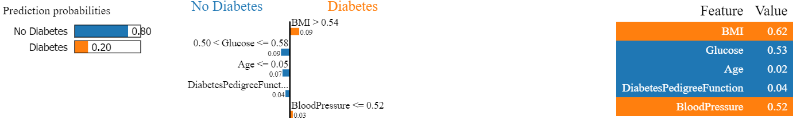

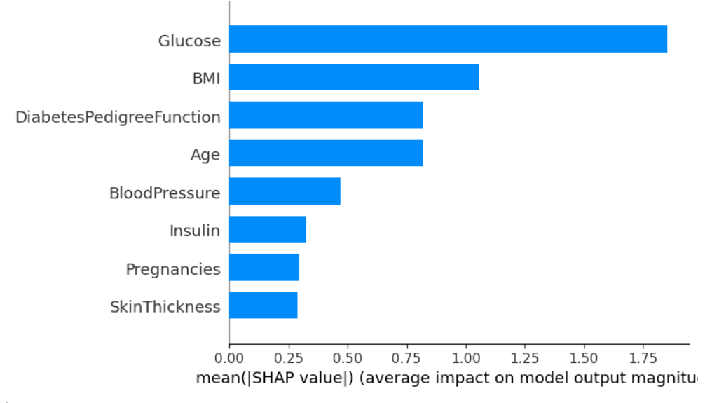

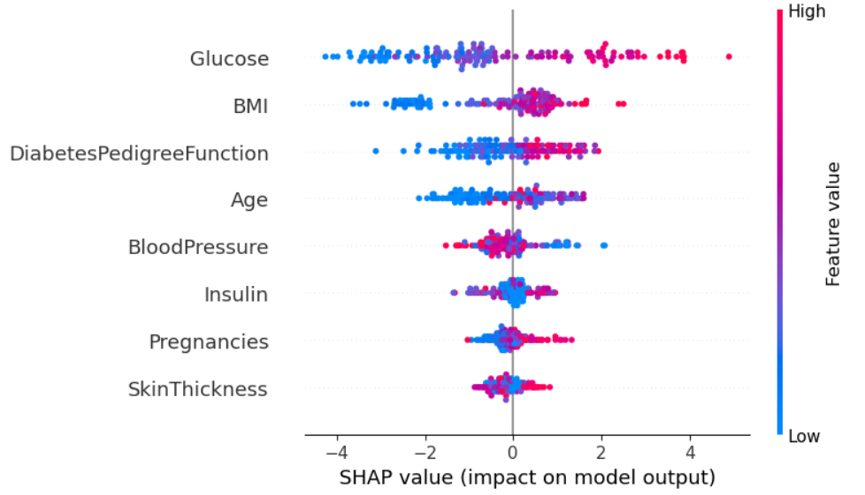

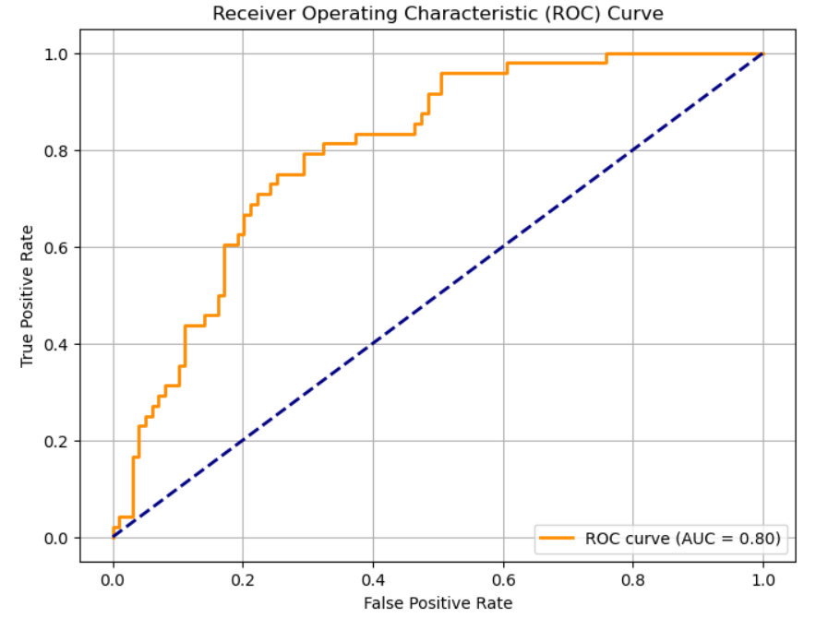

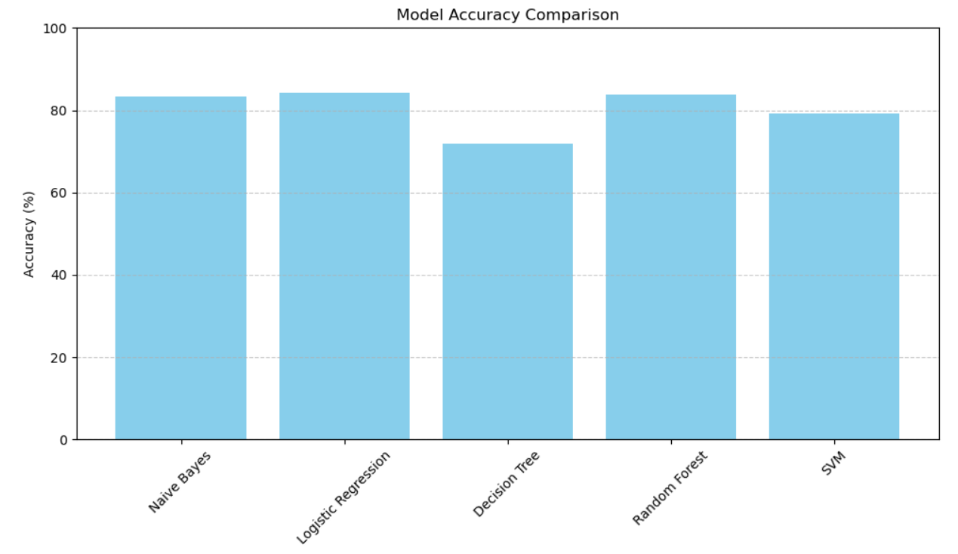

**Chapter 8**

**GUI Integration and System Deployment**

Although the core focus of this thesis is on predictive modeling, system usability is enhanced by an integrated graphical user interface (GUI):

* **GUI Design:**  
  The GUI is designed to be intuitive and user-friendly. Screens include login pages, dashboards for displaying prediction results, and data visualization panels.
* **System Integration:**  
  The deployed system integrates the machine learning models with the GUI, allowing healthcare providers to input patient data and receive predictions in real time.
* **Deployment Considerations:**  
  Details regarding the deployment environment, including server configuration, API endpoints, and security measures (user authentication and data encryption), are discussed.
* **User Feedback:**  
  Preliminary user testing results are presented, emphasizing the importance of usability and real-world applicability in clinical settings.

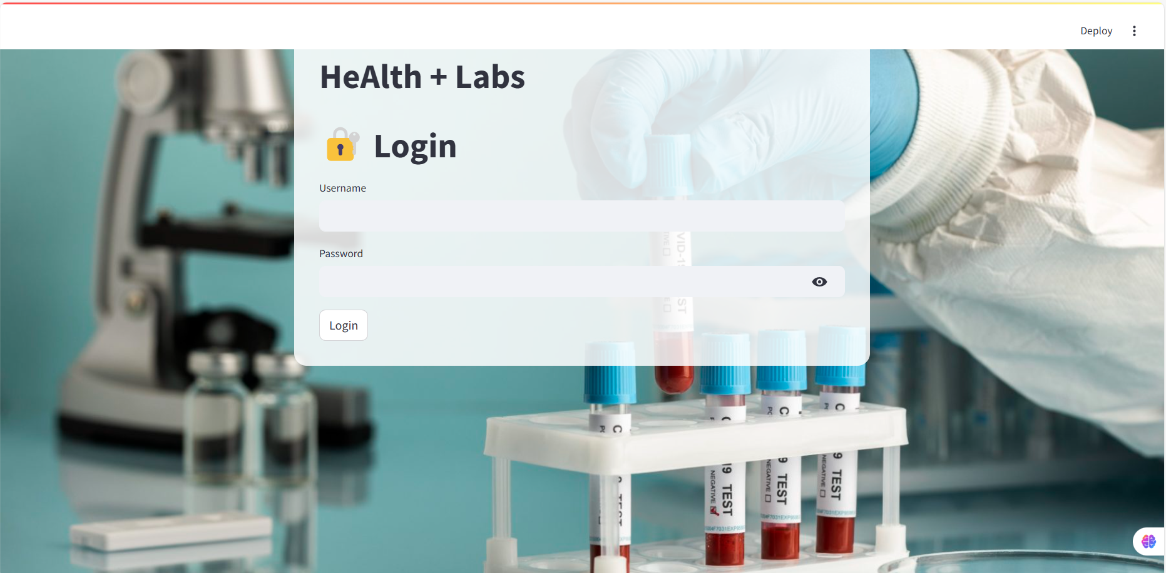

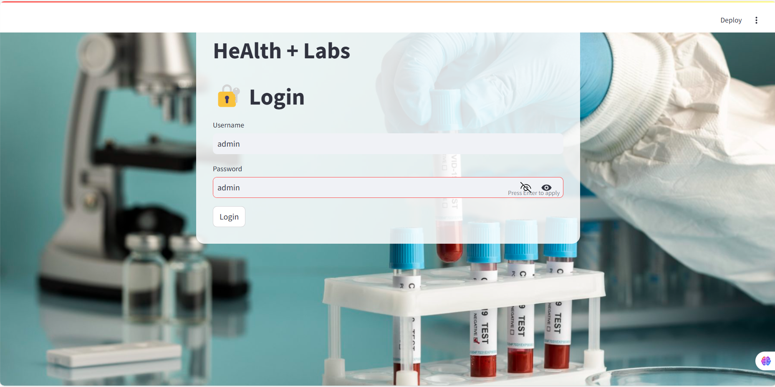

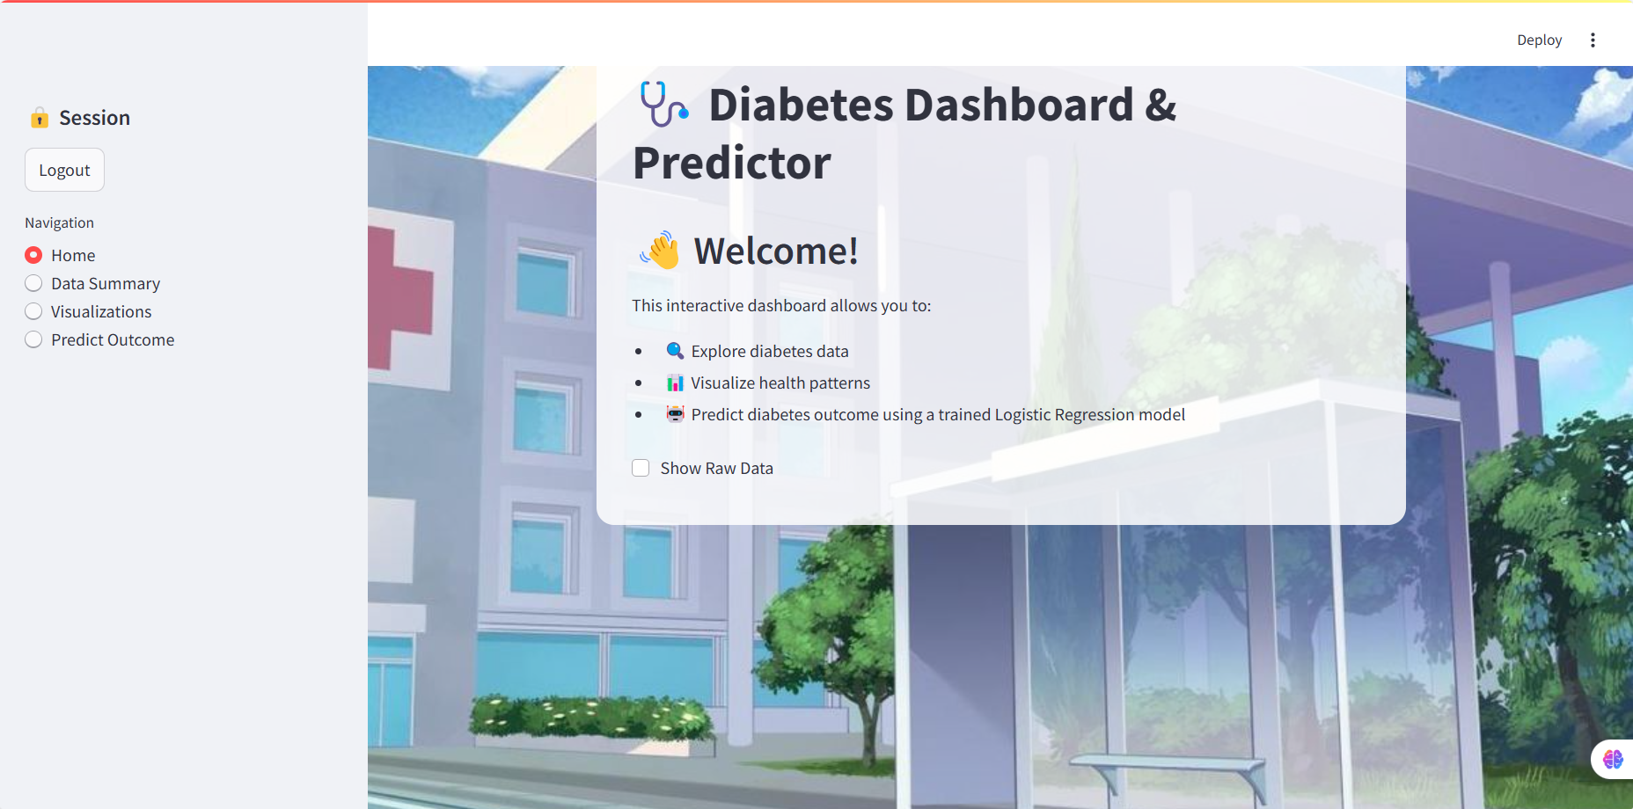

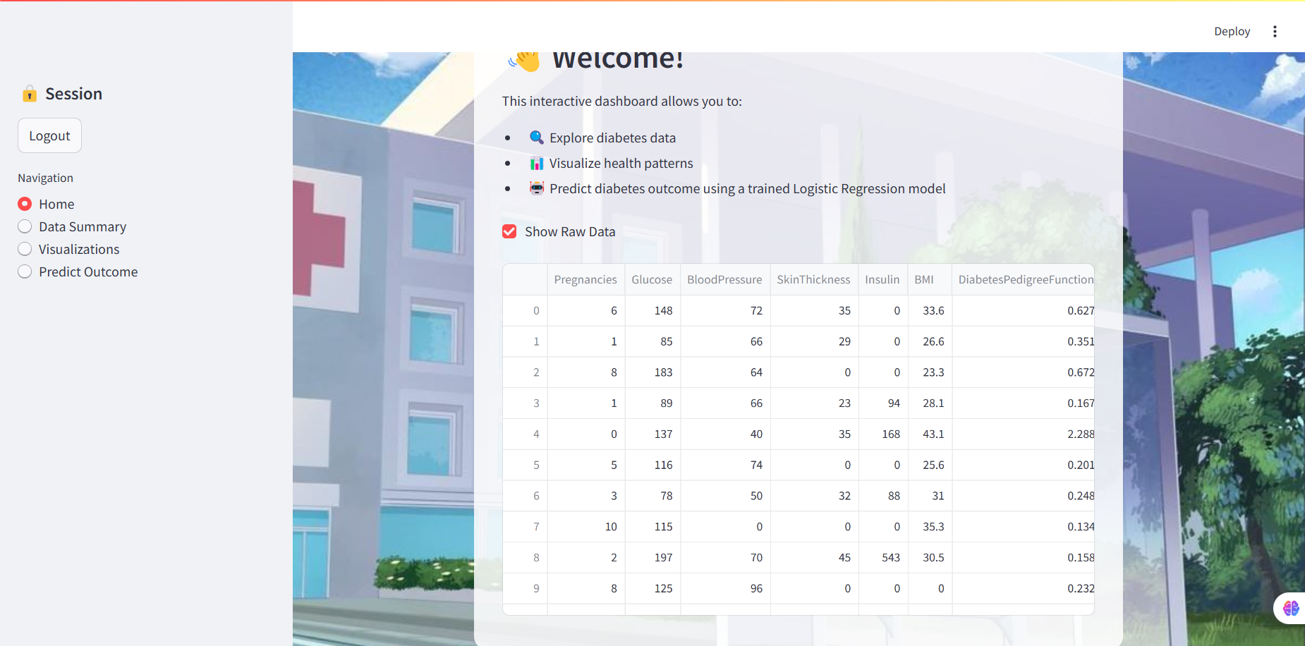

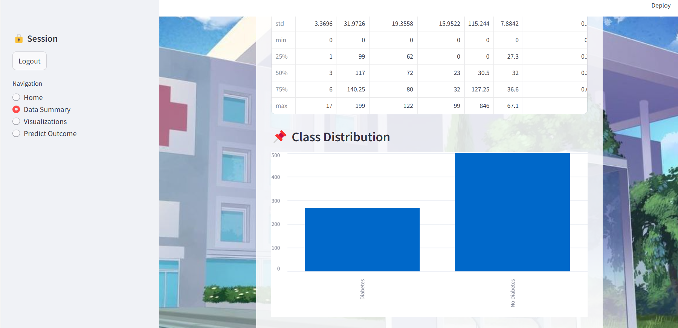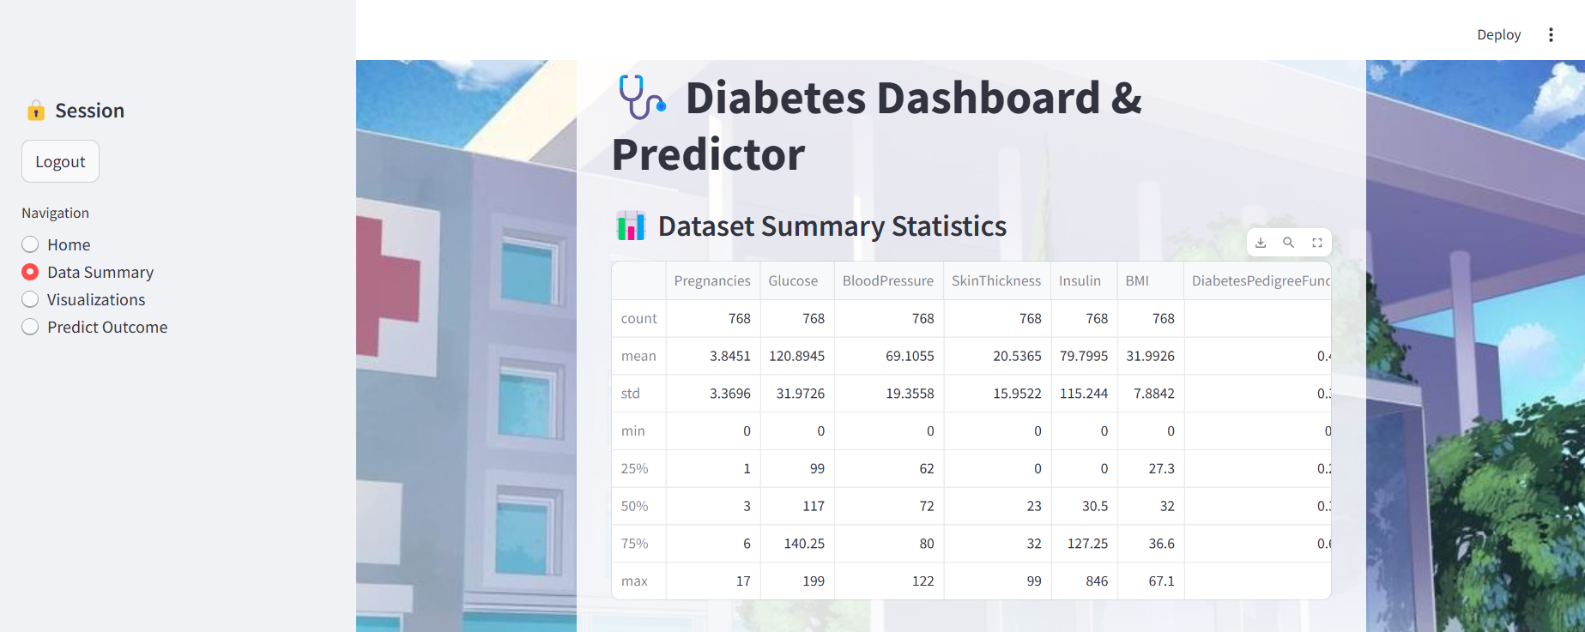

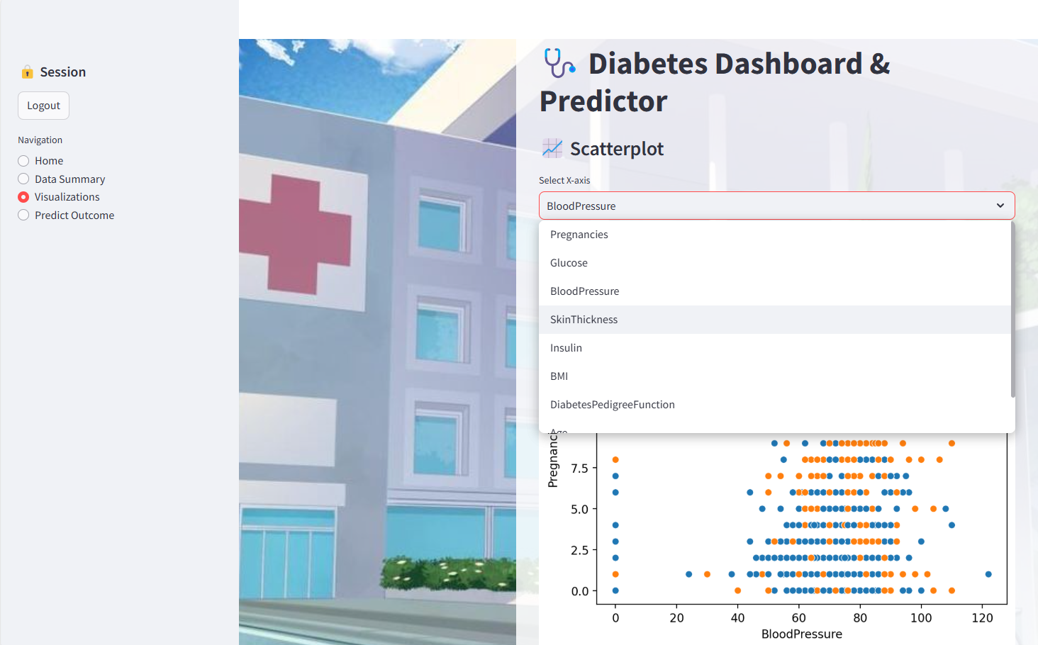

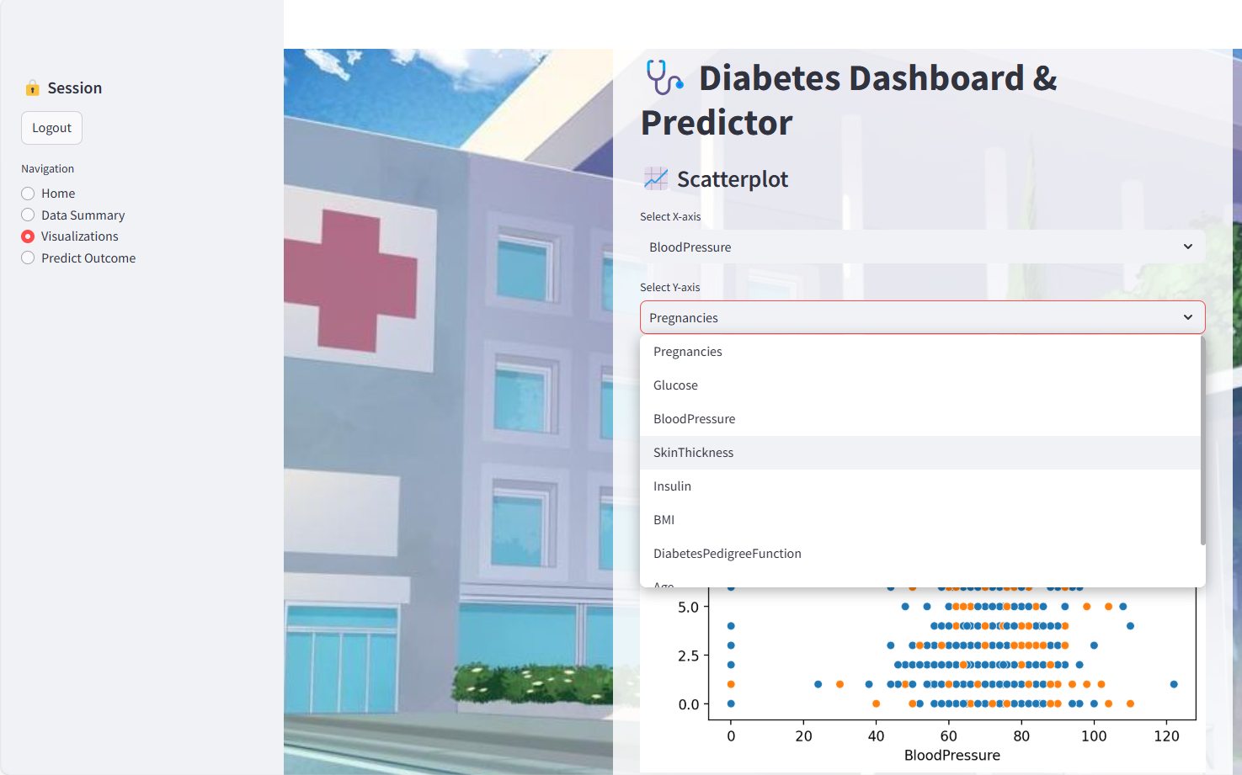

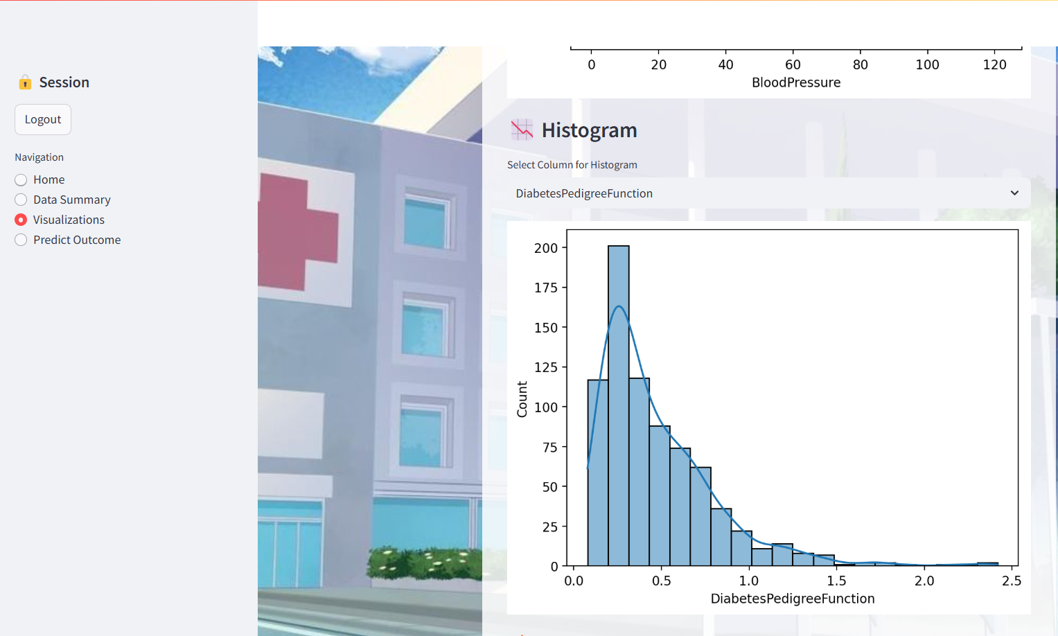

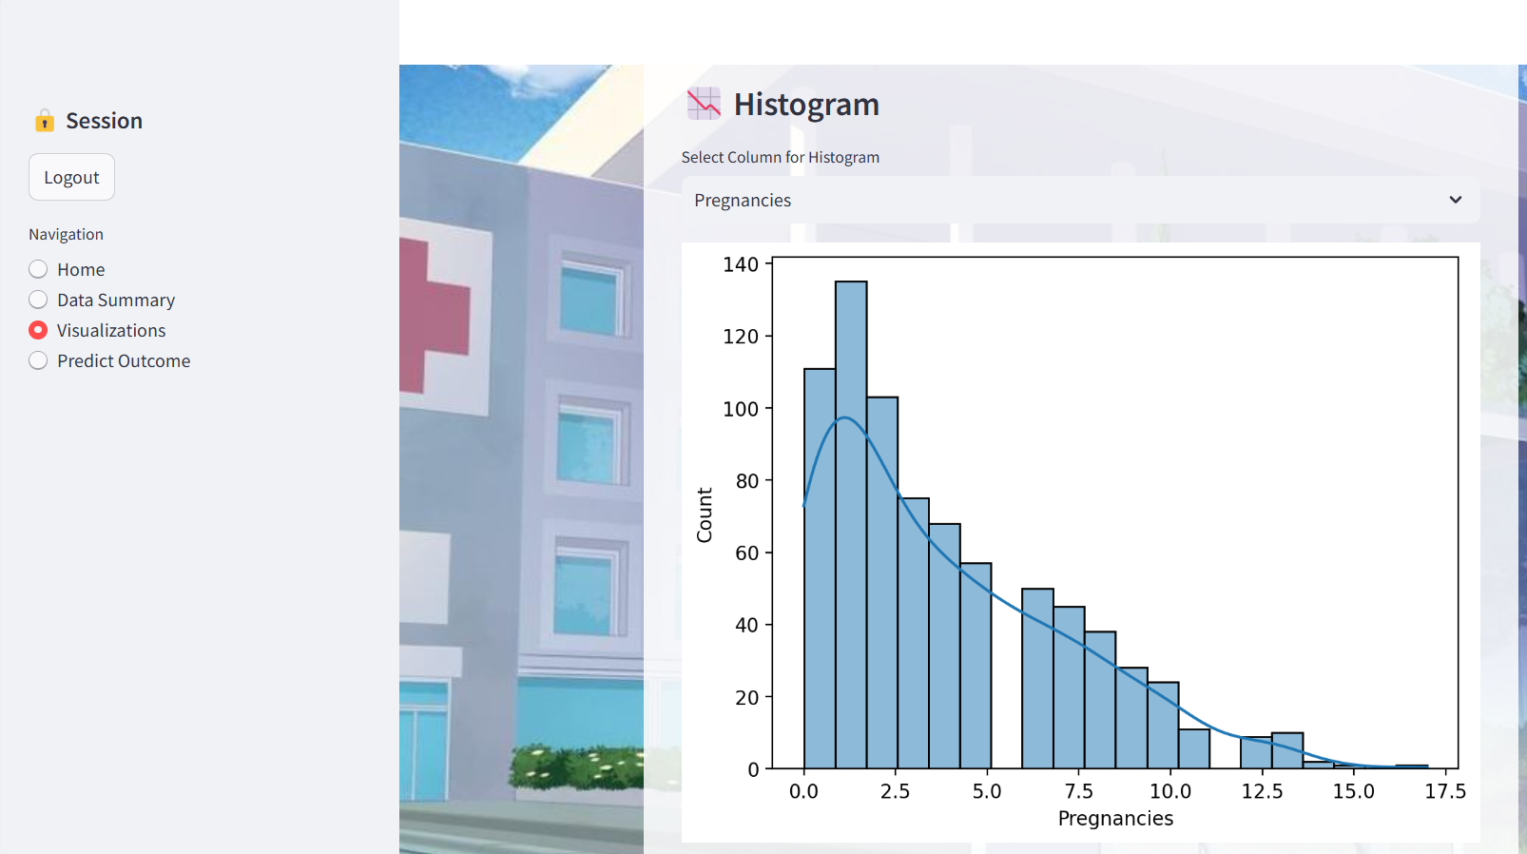

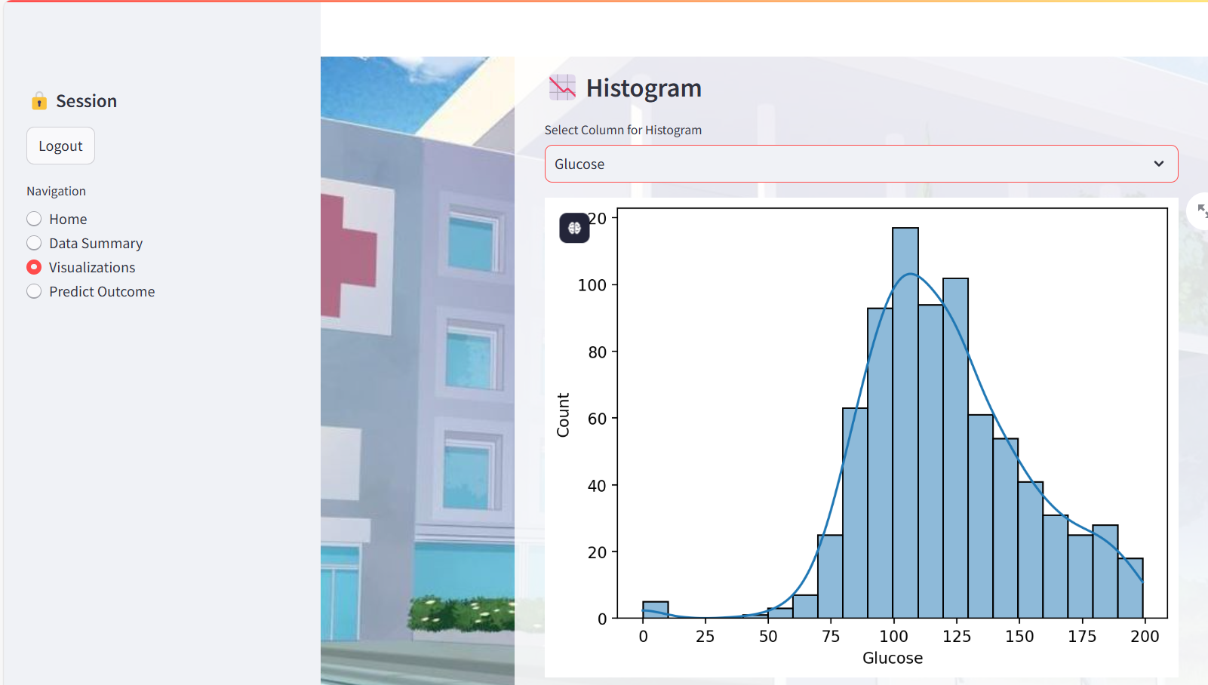

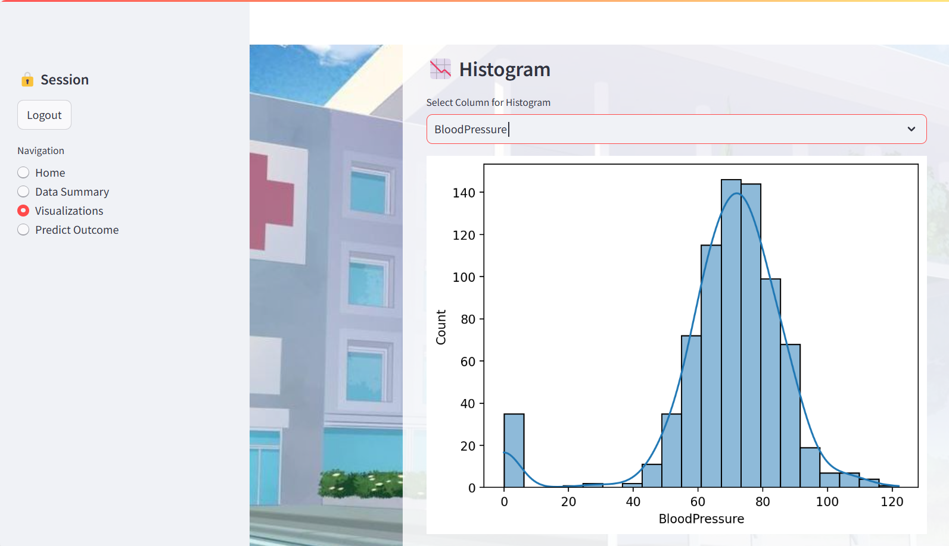

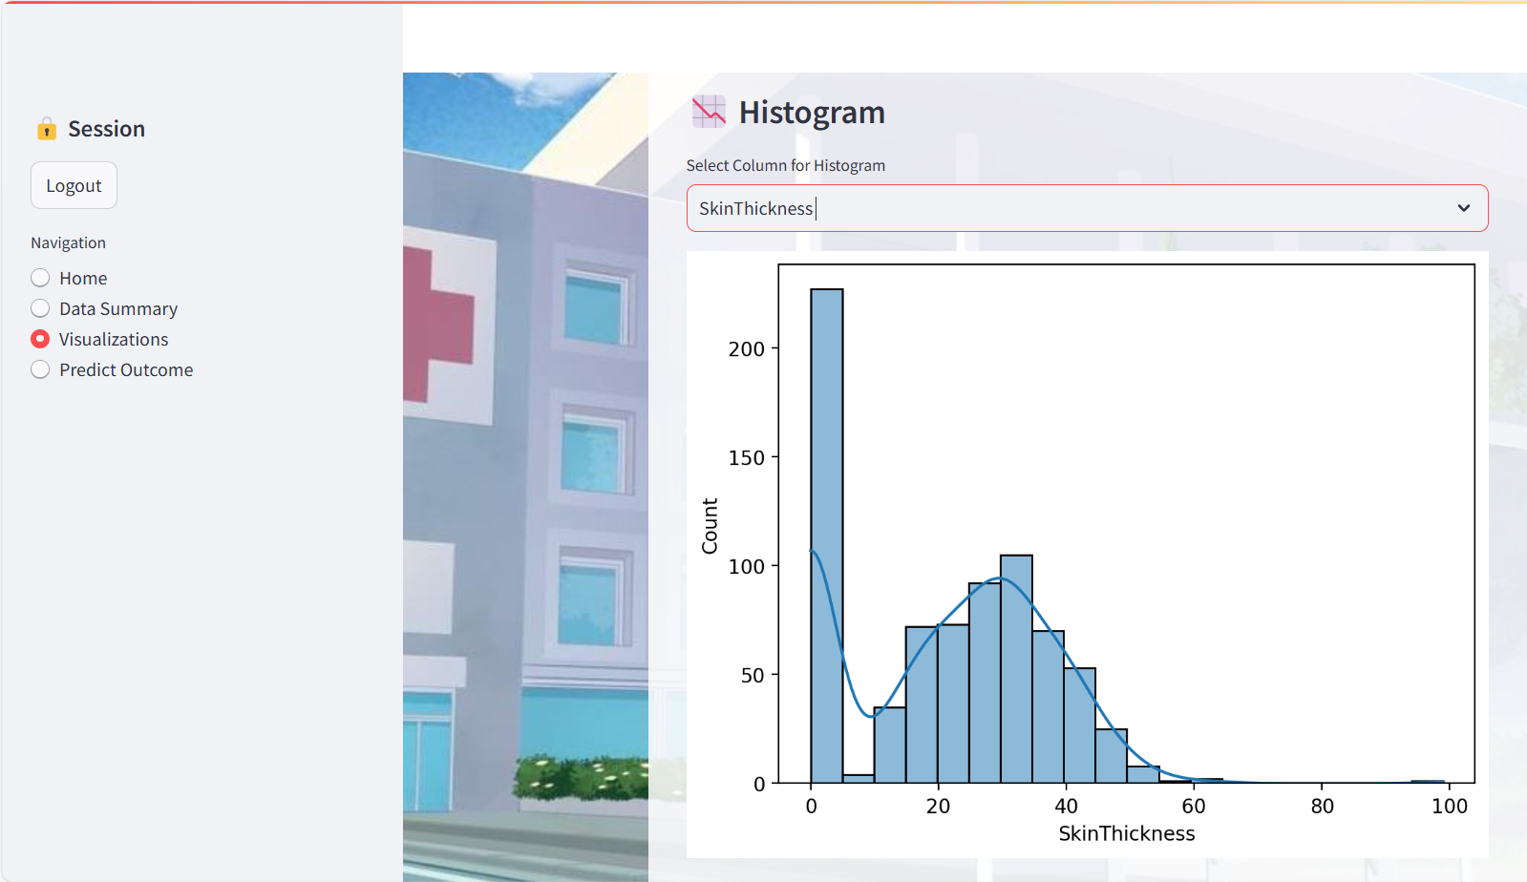

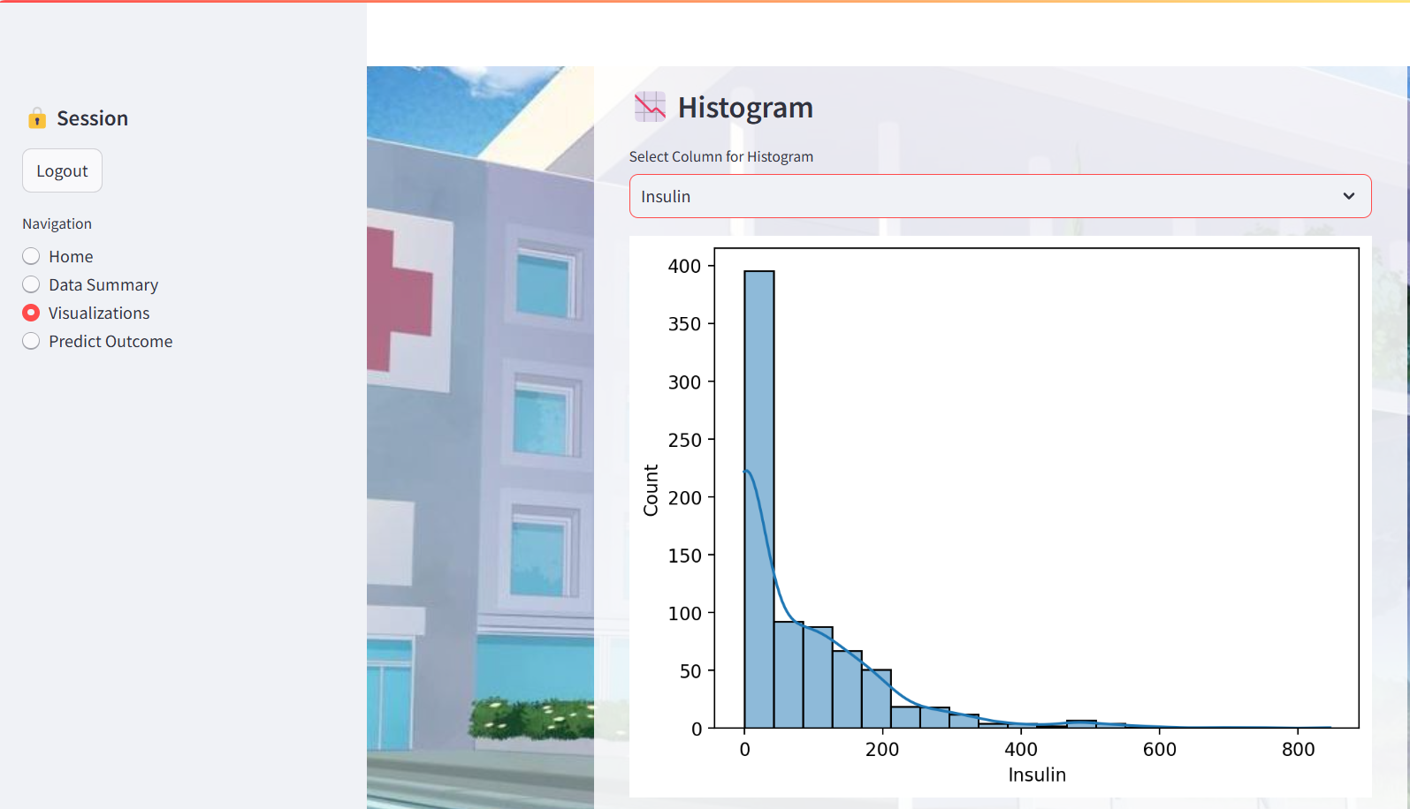

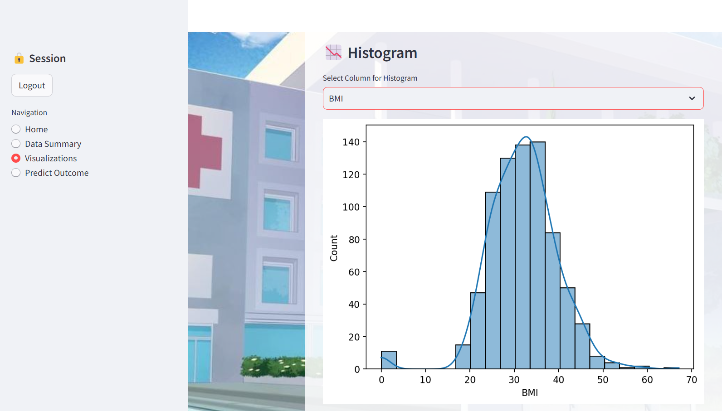

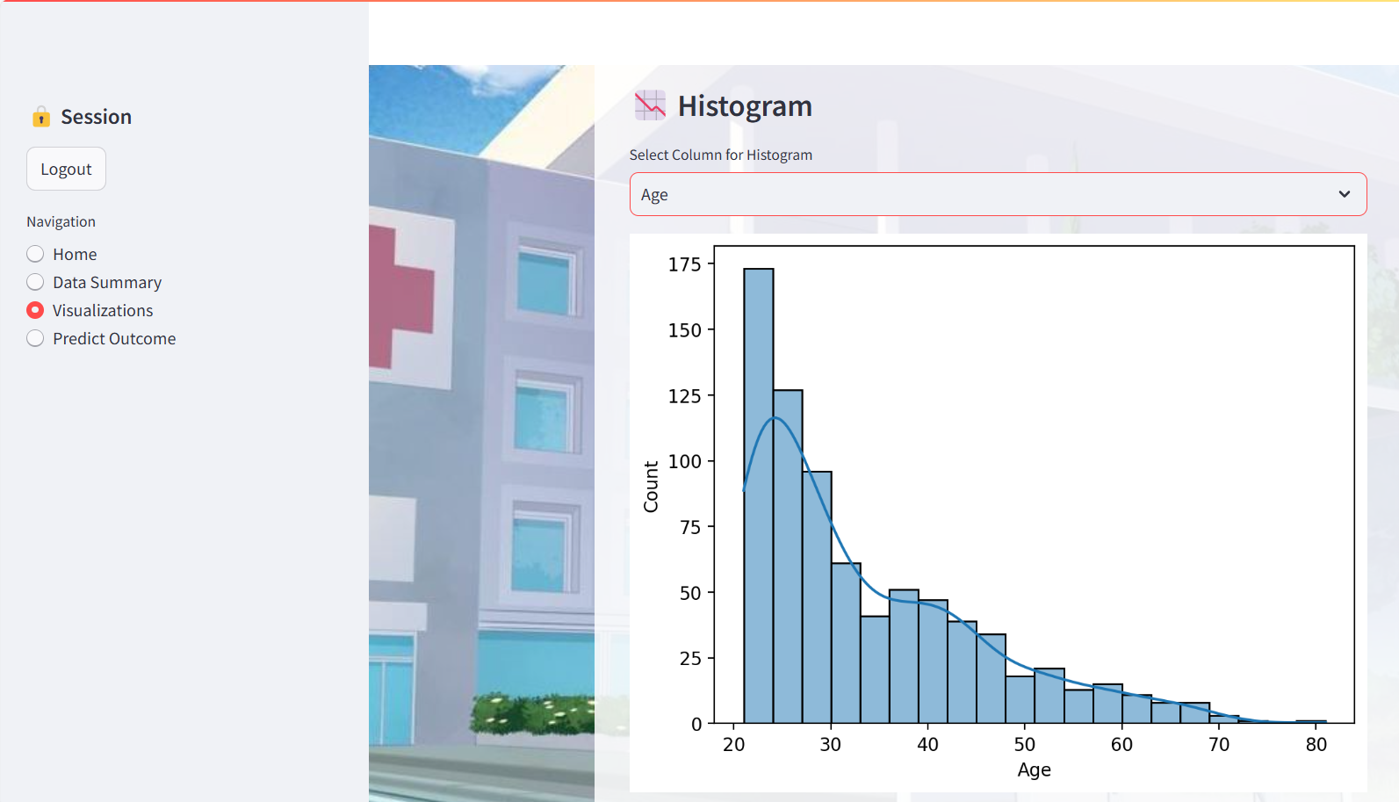

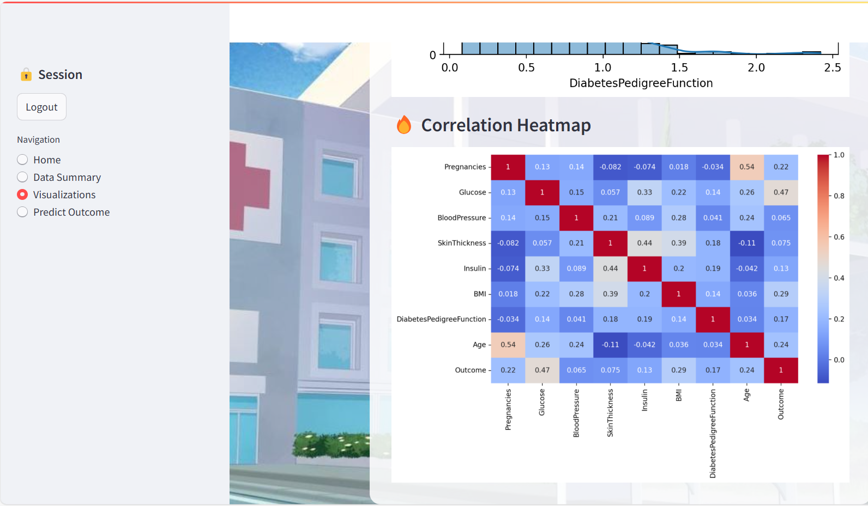

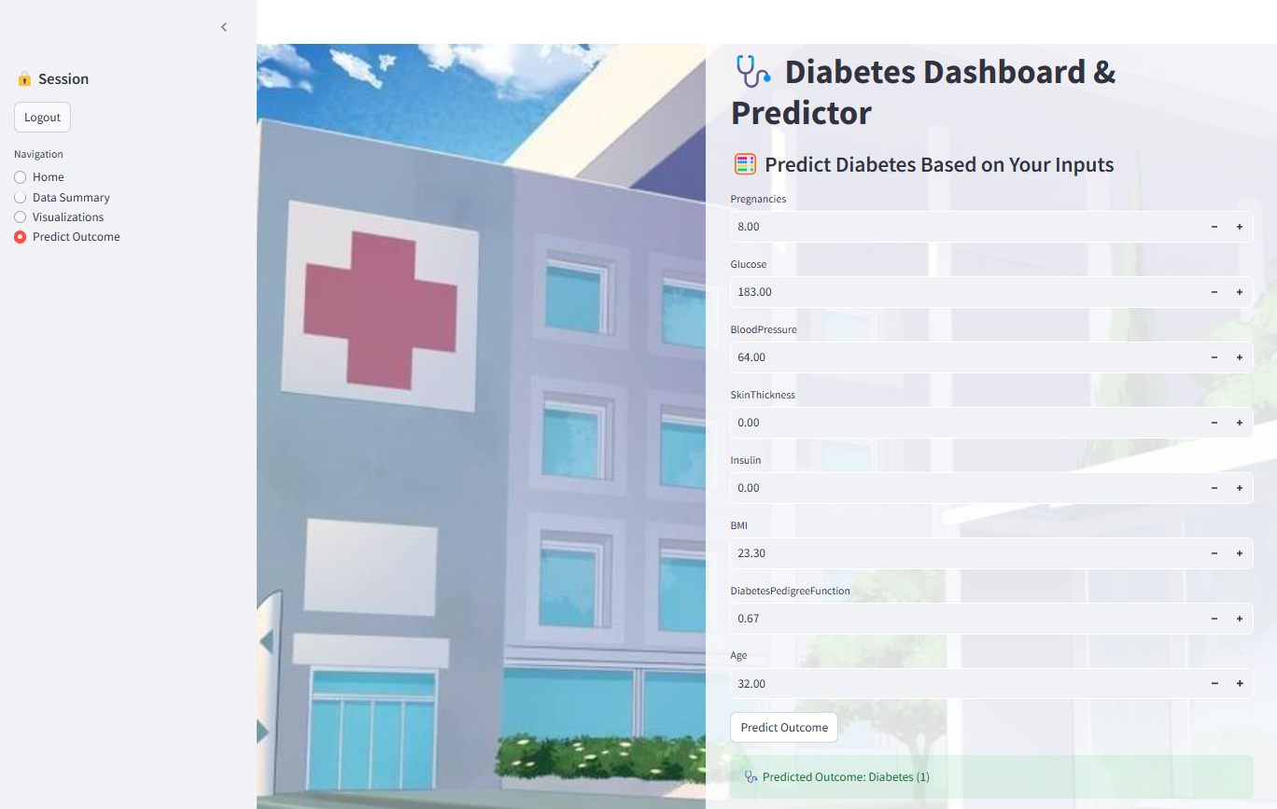

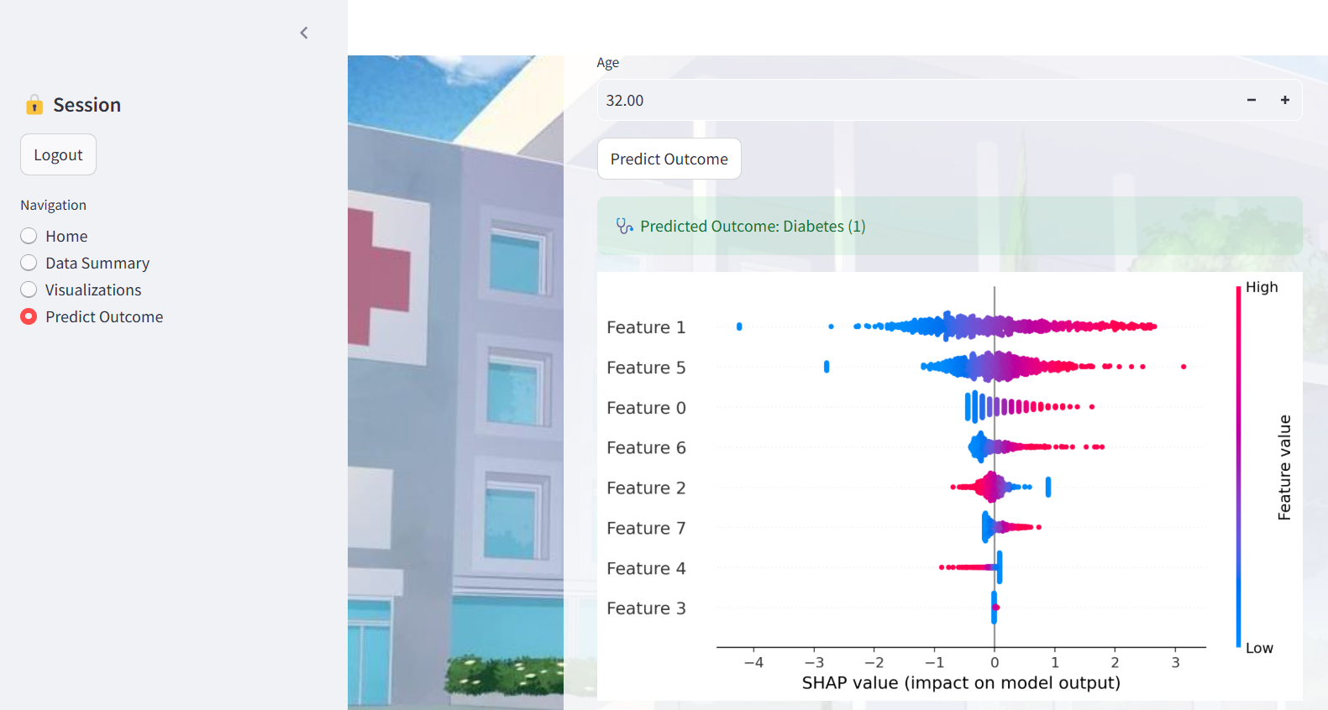

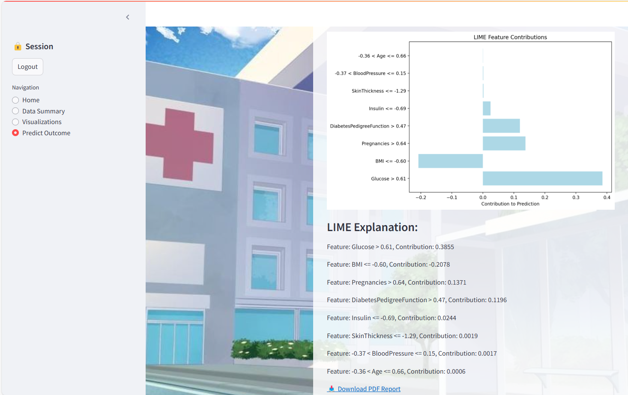

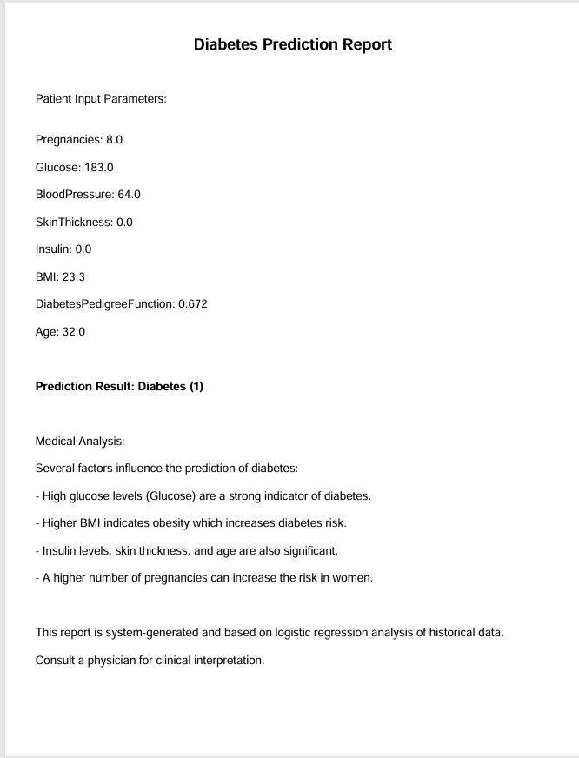

**Chapter 9**

**Appendix**

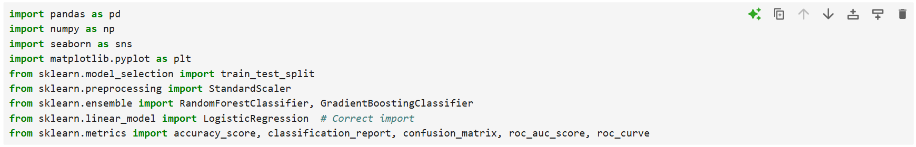



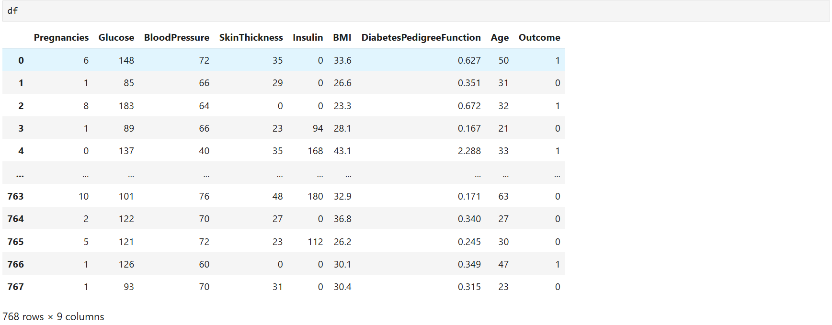

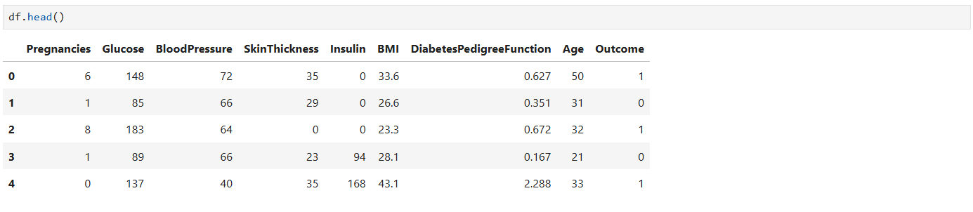

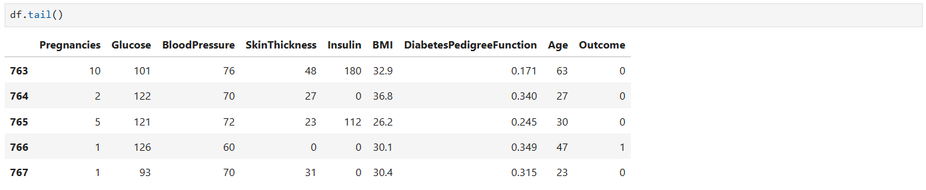

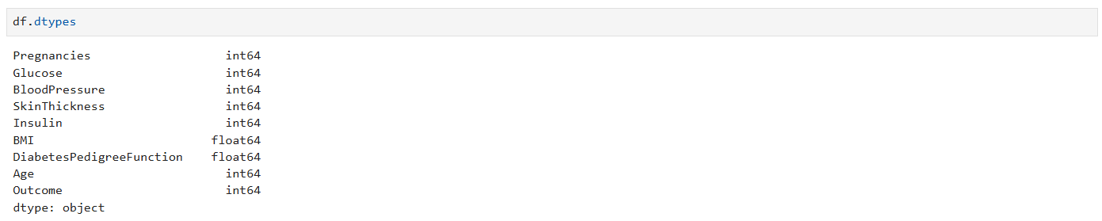

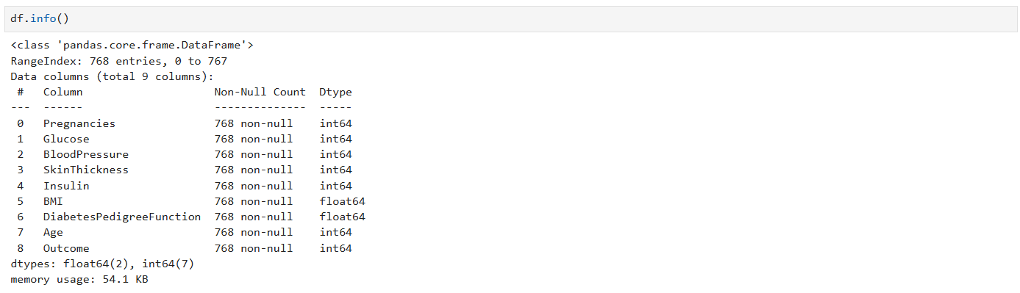



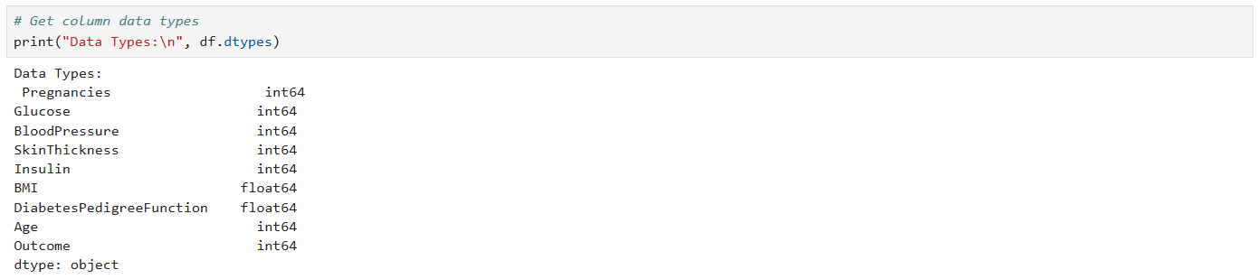

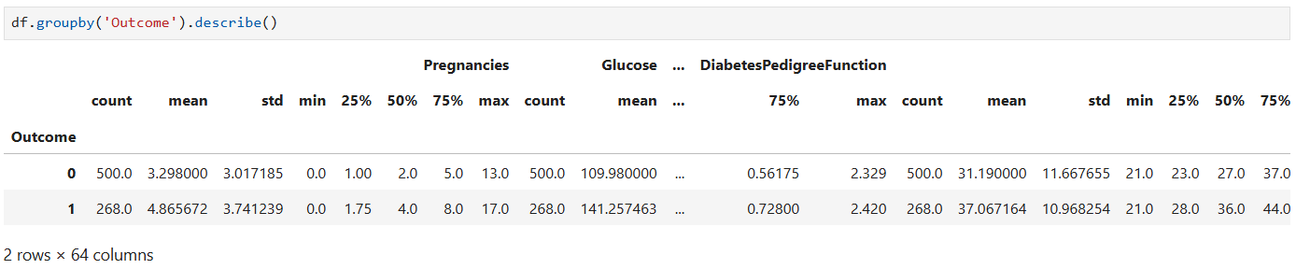

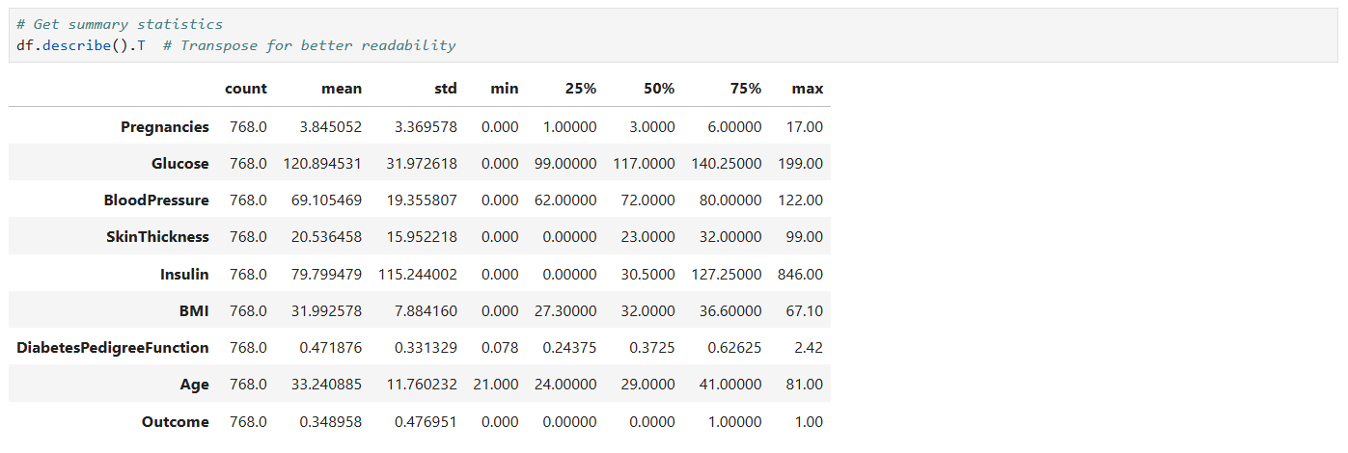

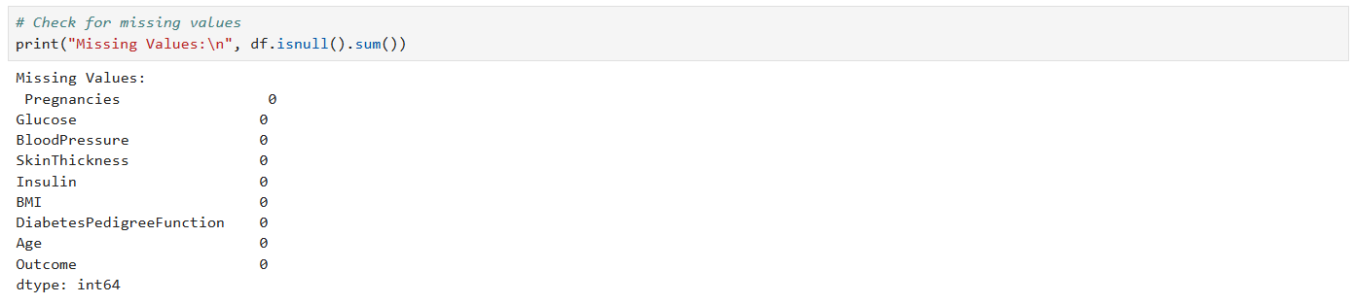



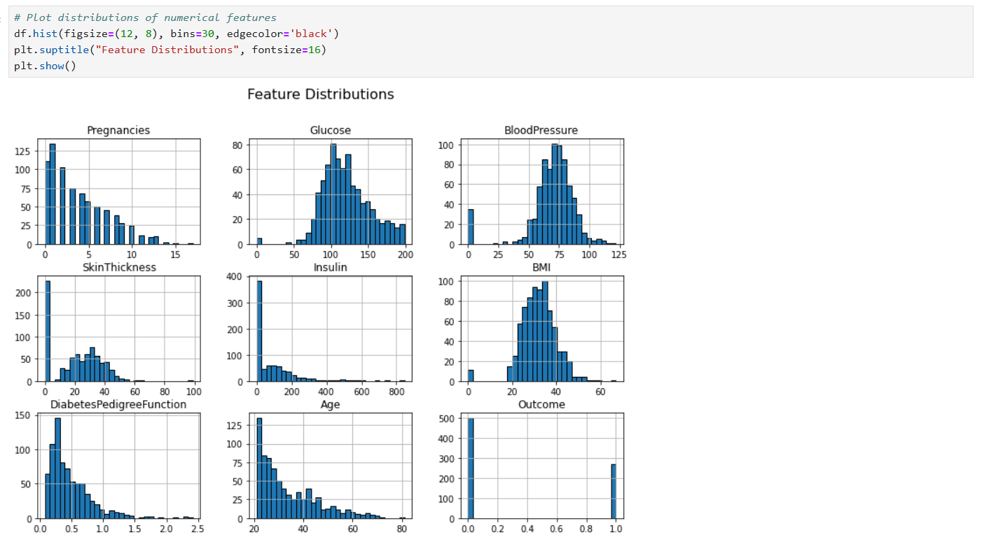

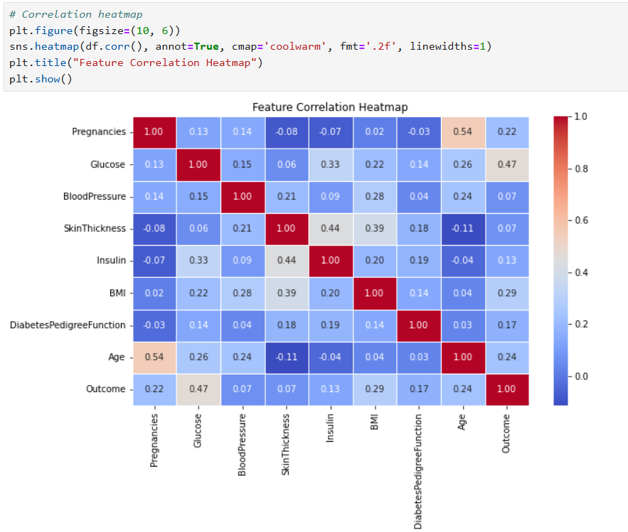

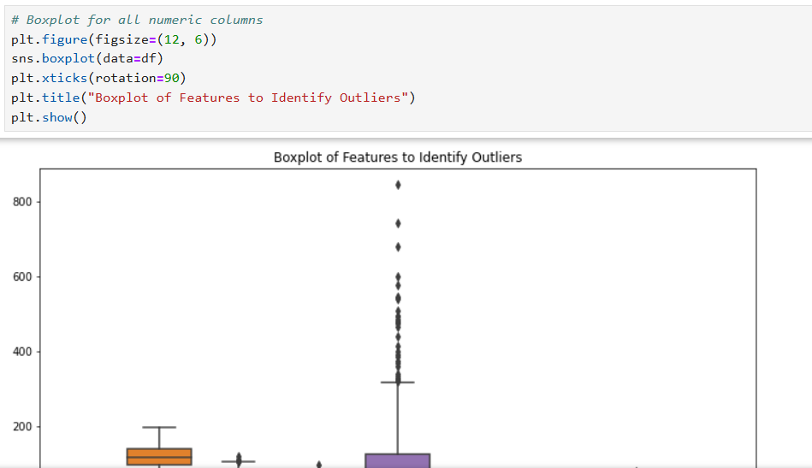

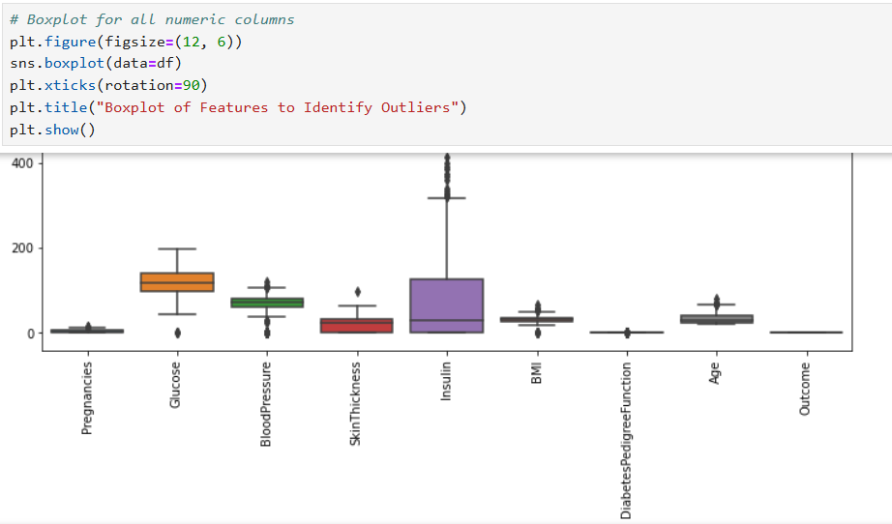

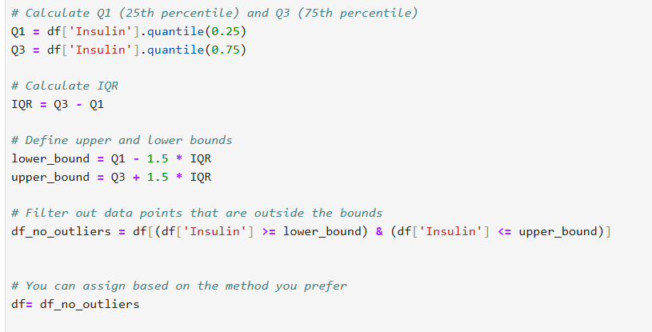

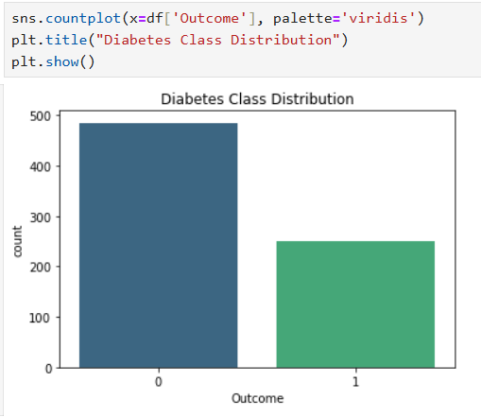

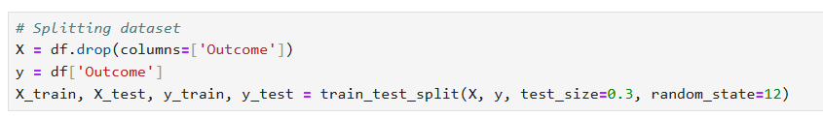

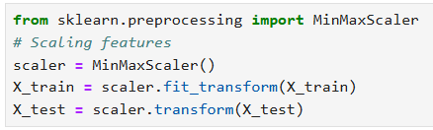

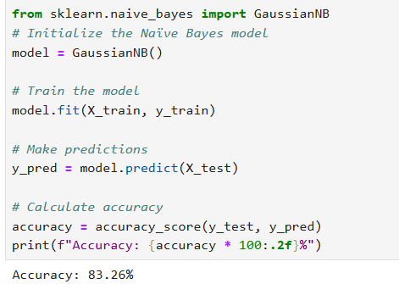

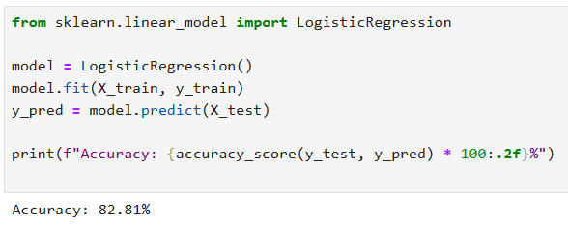

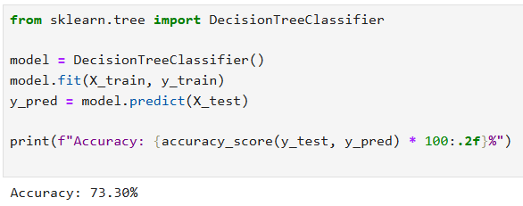

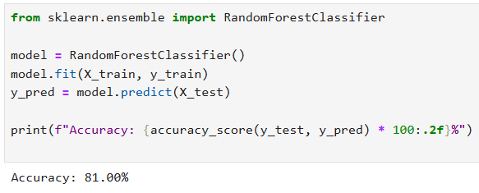

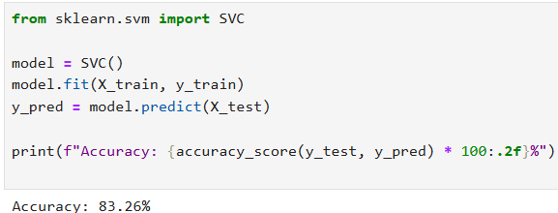

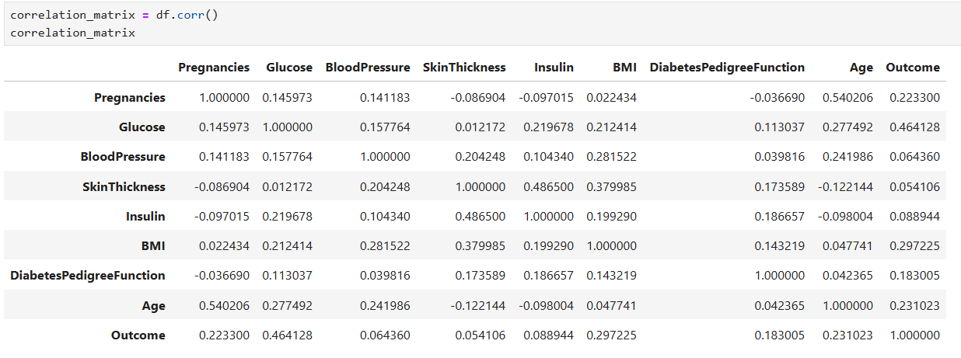

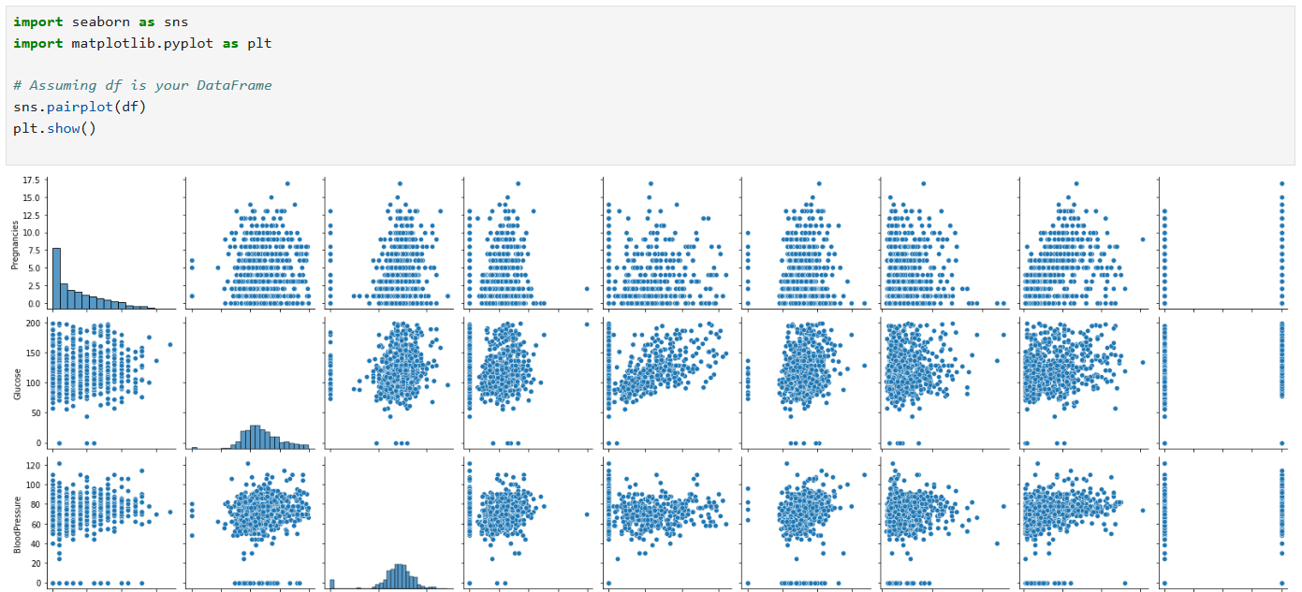

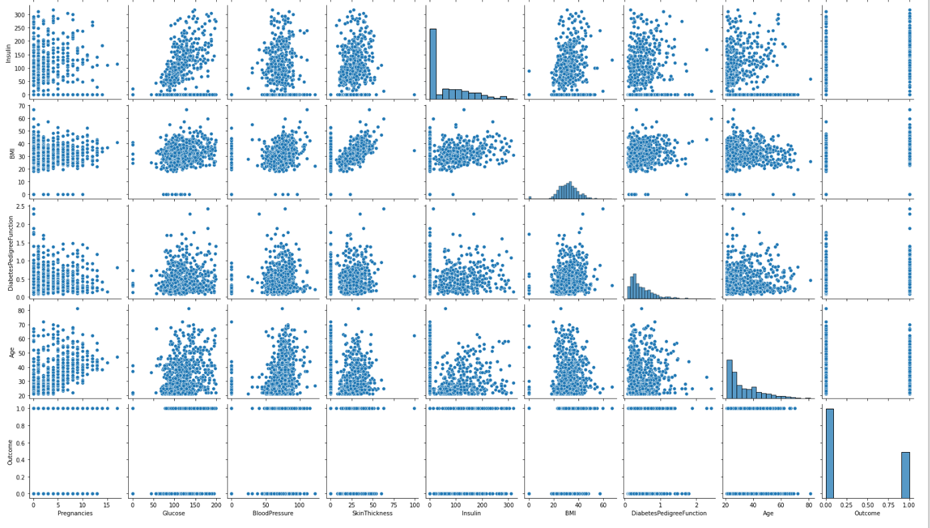

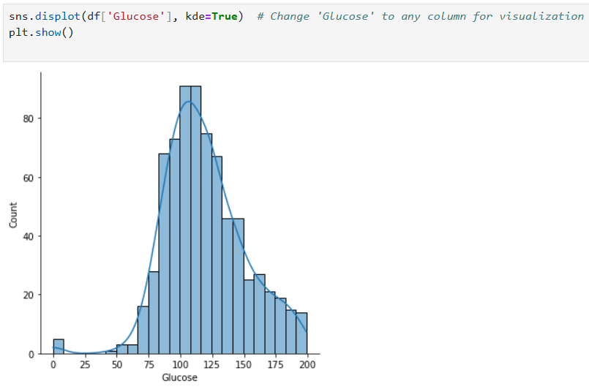

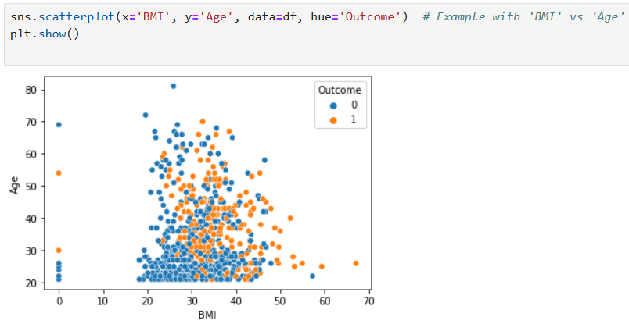

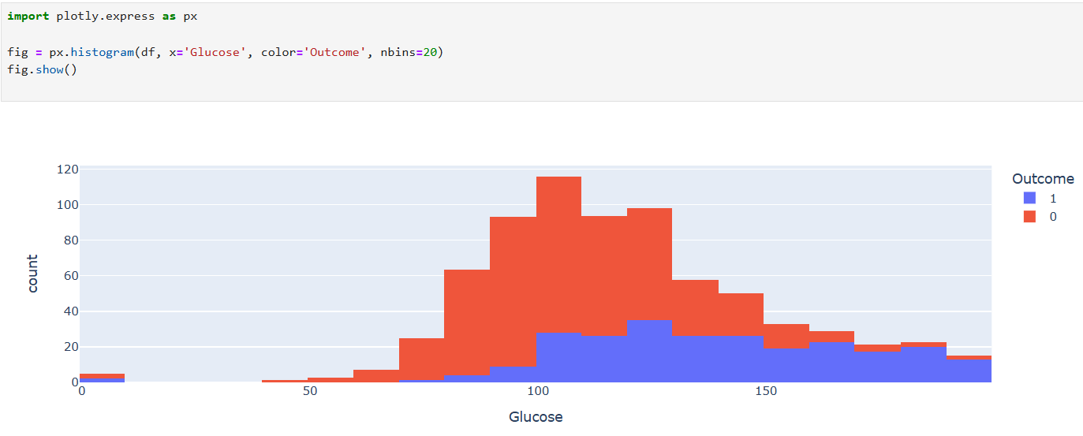

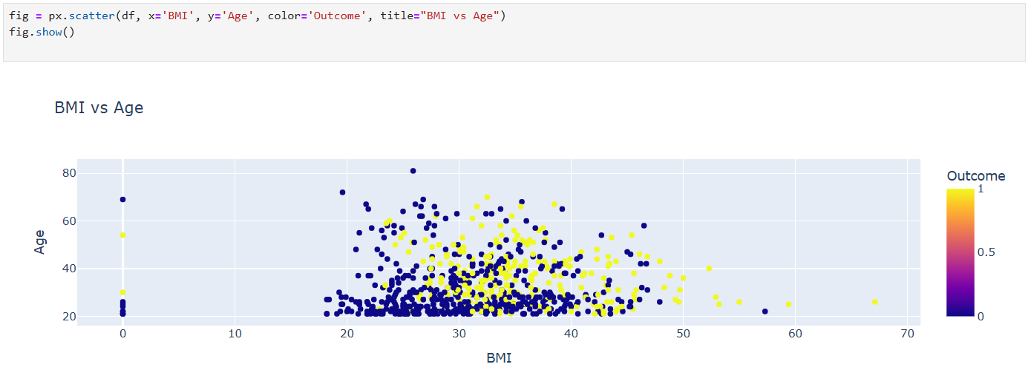

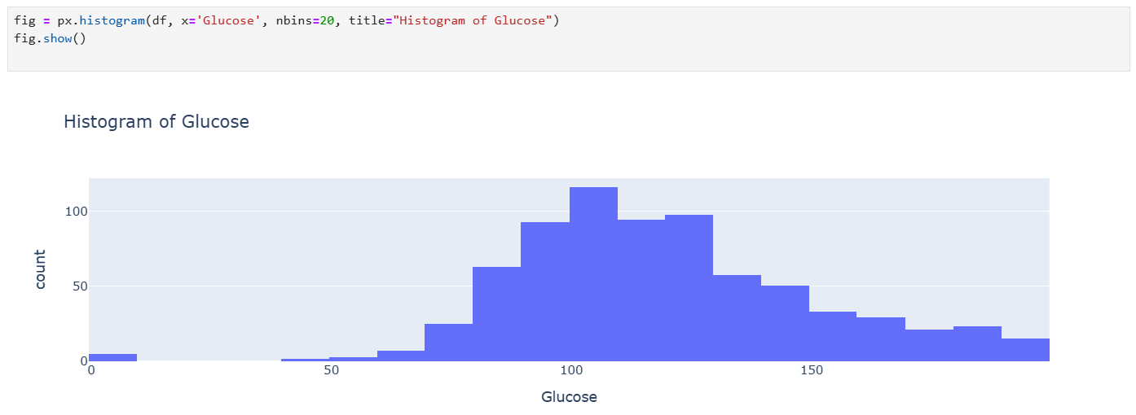

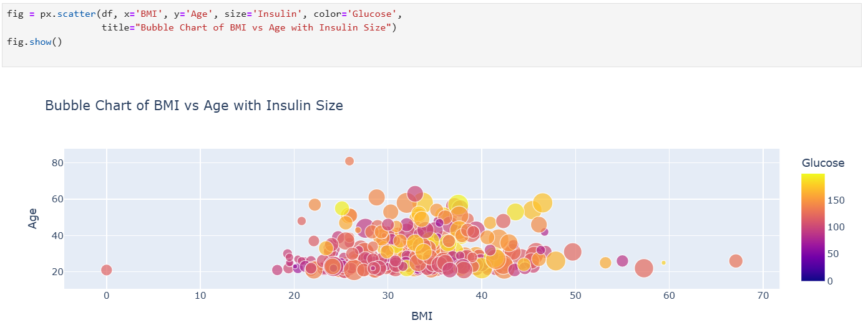

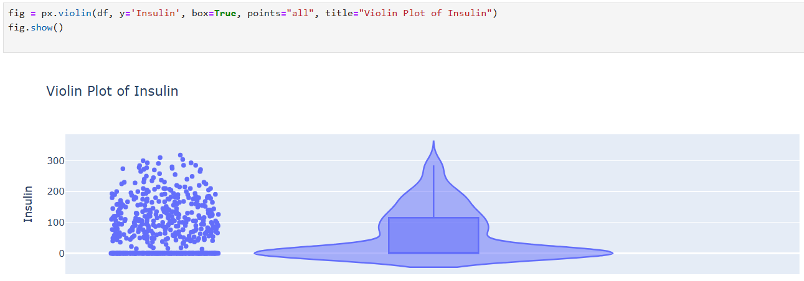

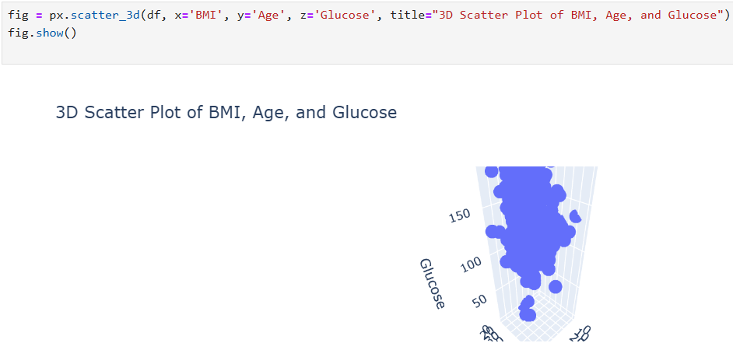

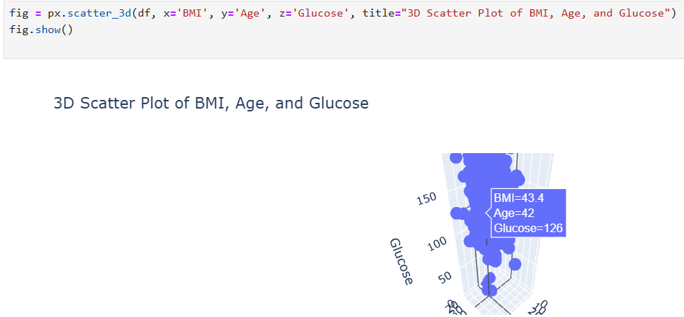

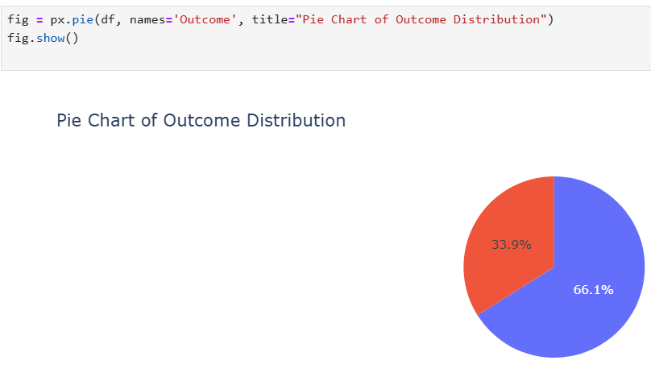

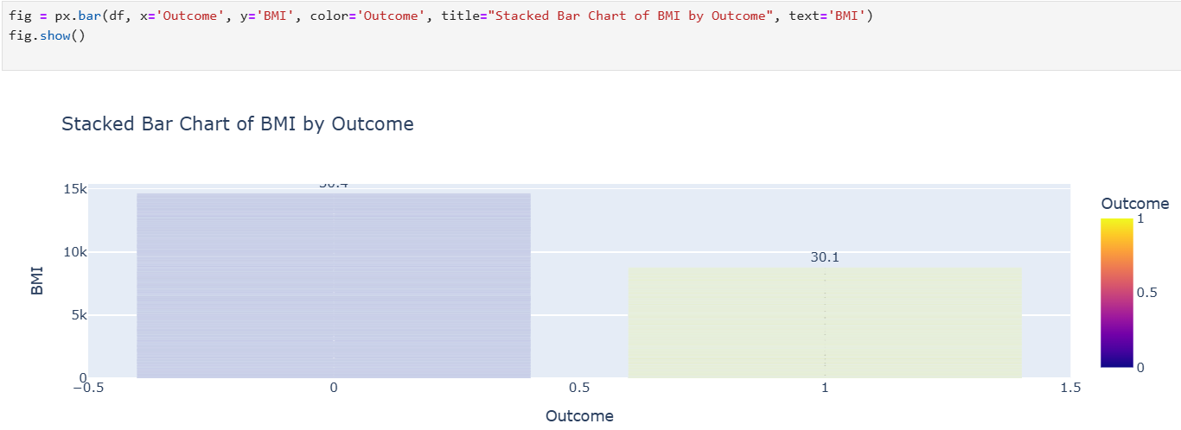

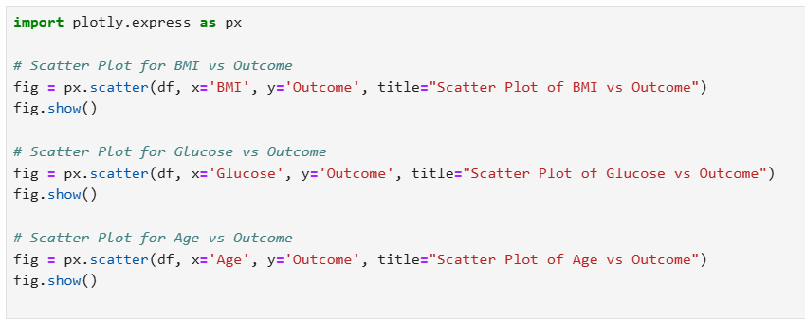

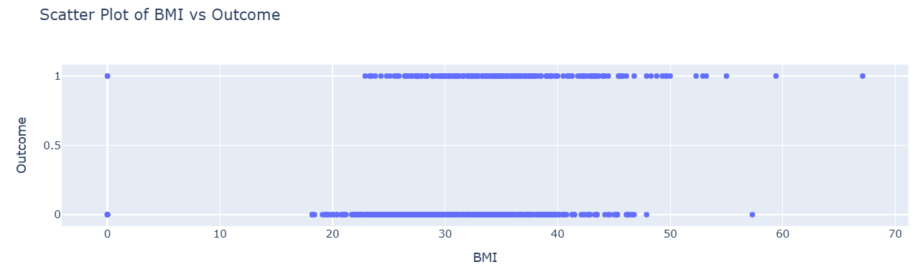

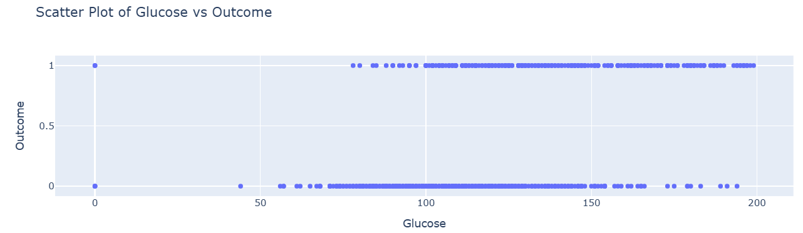

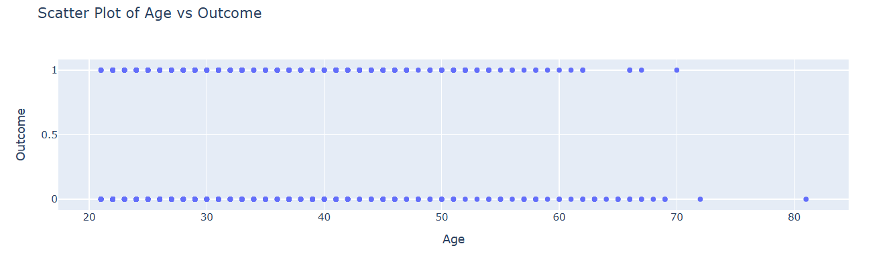

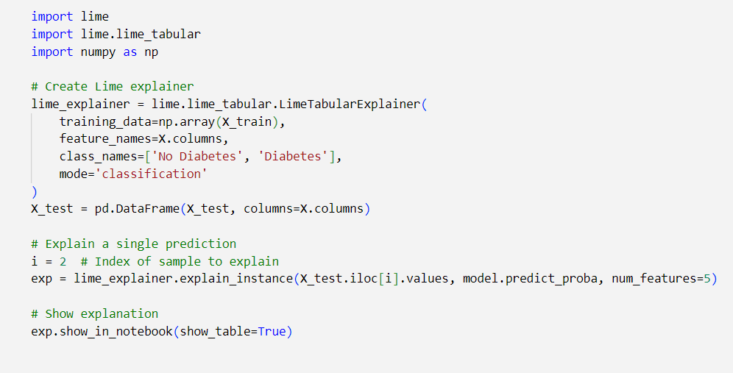

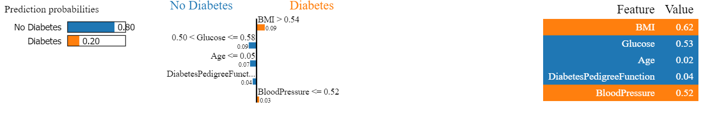

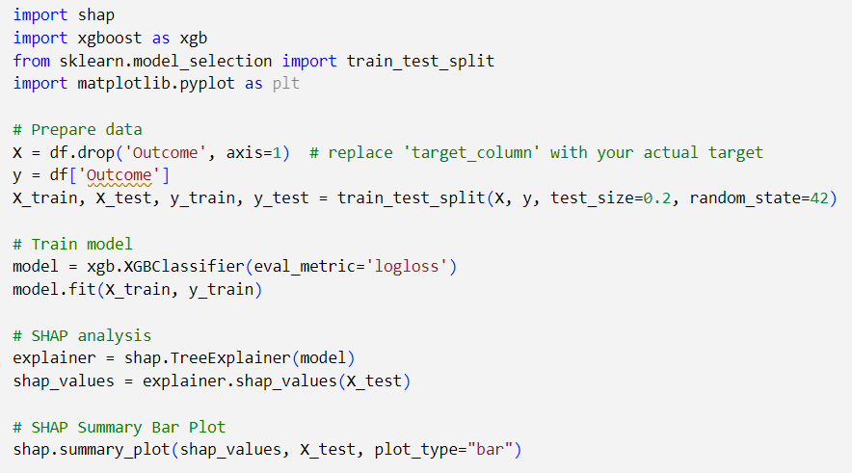

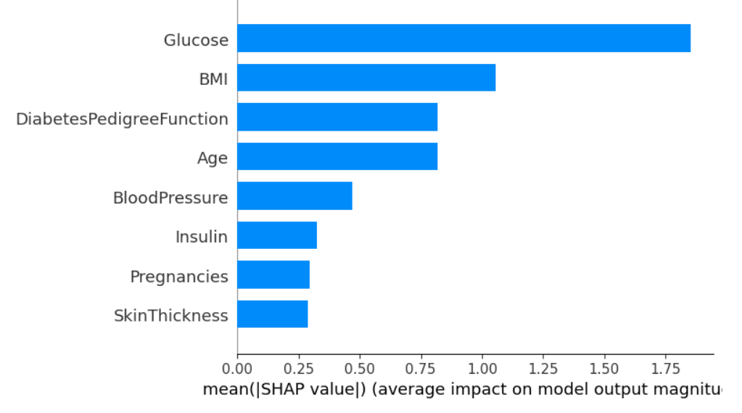

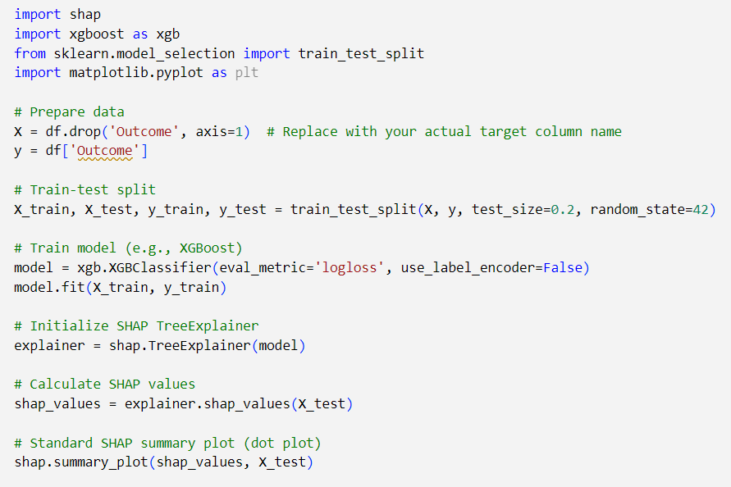

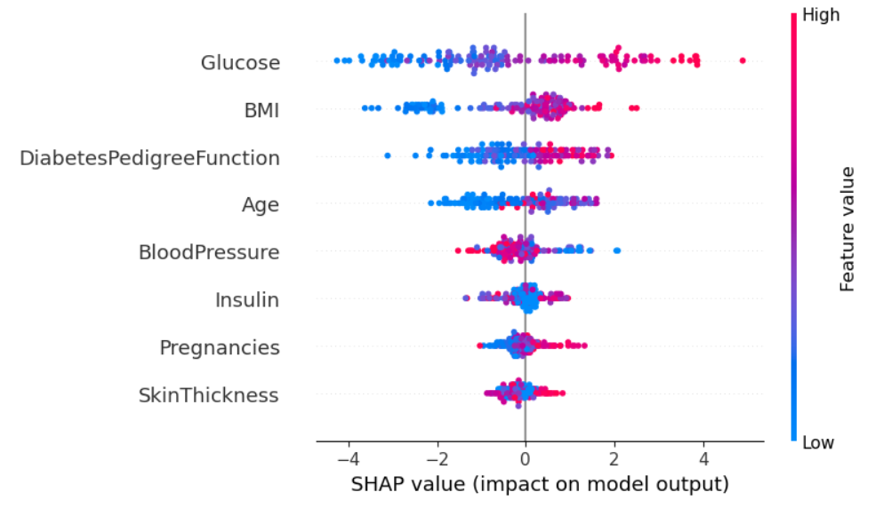

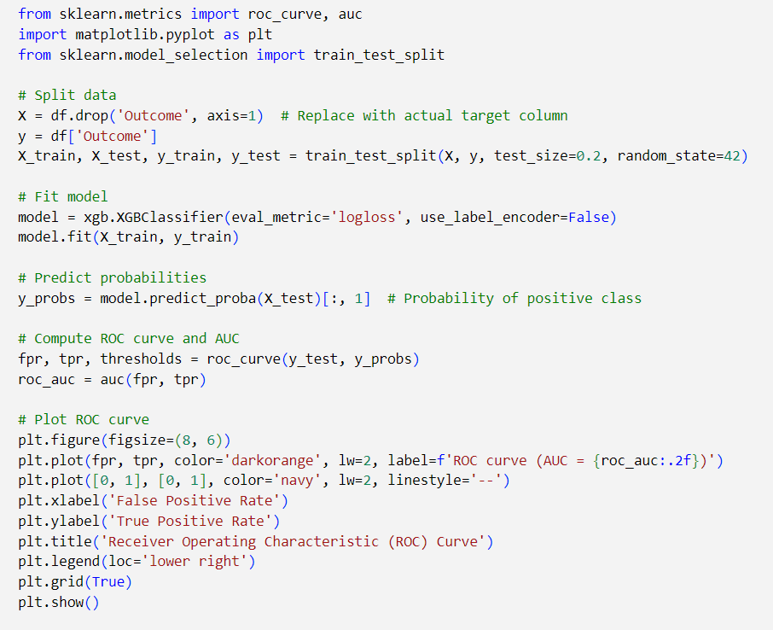

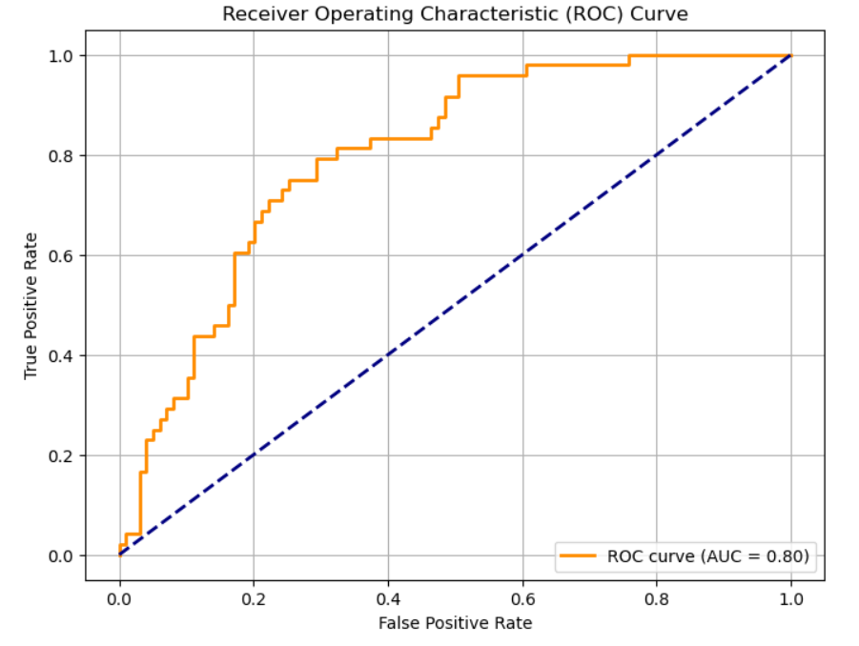

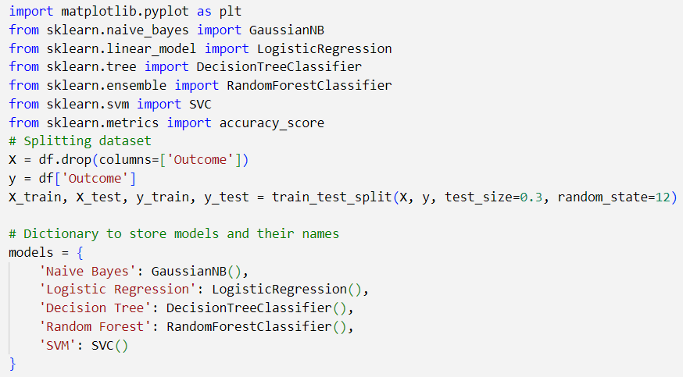

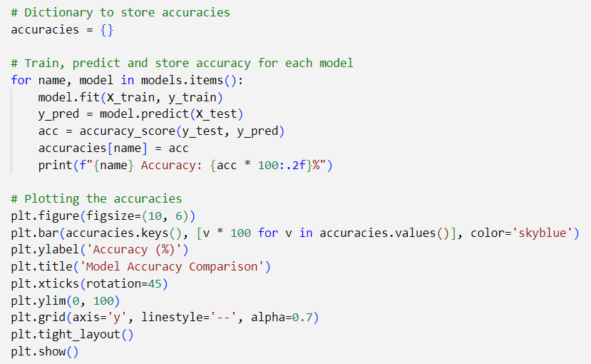

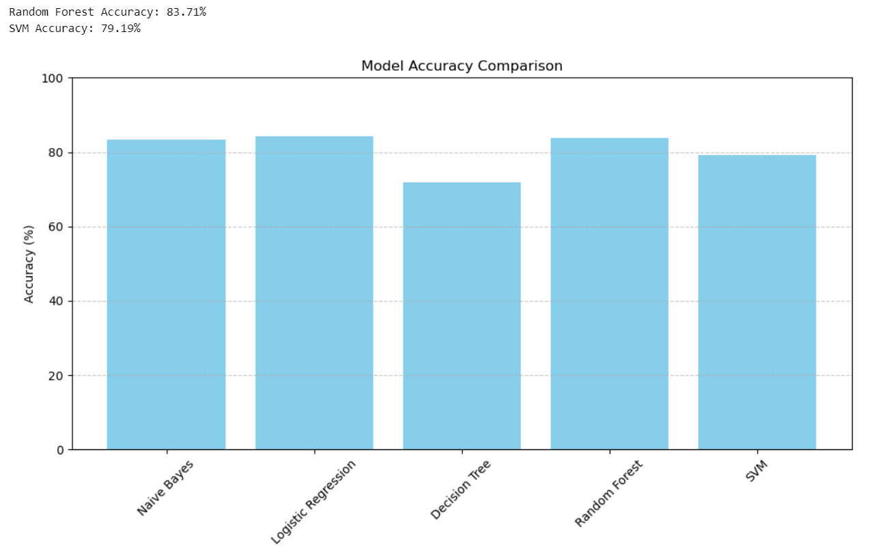

**Chapter 10**

**Conclusion and Future Scope**

In conclusion, this thesis demonstrates that machine learning models—particularly ensemble methods—can effectively predict diabetes from patient data.

The study highlights the critical role of data preprocessing, model evaluation, and interpretability in developing reliable diagnostic tools.

**Key Findings:**

* Ensemble methods (Random Forest and Gradient Boosting) show higher predictive accuracy compared to simpler models.
* Interpretability techniques (SHAP and LIME) provide valuable insights into model decisions, increasing clinician trust.
* The integrated system architecture and GUI facilitate practical deployment in healthcare environments.

**Future Research Directions:**

* **Deep Learning:** Further research into deep learning techniques may yield even higher predictive performance.
* **Dataset Expansion:** Incorporating larger and more diverse datasets can enhance model robustness.
* **Clinical Integration:** Developing full-scale clinical decision-support systems that integrate with hospital management systems.
* **Real-Time Analytics:** Exploring real-time data analytics and continuous learning models to adapt to new medical insights.

The work presented in this thesis forms a foundation for future innovations in the field of medical diagnostics, paving the way for smarter, faster, and more interpretable healthcare solutions.